|  |
| --- |
|  |
| Delphian  KEELER-3.0 User Manual |
| **Version 01.01.05** |



**Revision History**

|  |  |  |  |
| --- | --- | --- | --- |
| **Version #** | **Description** | **Date** | **Done By** |
| 01.01.01 | Write KEELER user guide | **June 1, 2015** | Nirav |
| 01.01.02 | Formatting and edit some content & FAQ | **June 5, 2015** | Nirav |
| 01.01.03 | App’s screen shots and settings flow are updated | **July 30, 2015** | Paresh |
| 01.01.04 | Device Diagnostics flow is added | **Aug 17, 2015** | Paresh |
| 01.01.05 | Updated SR Portal | **Aug 24, 2015** | Heer |
|  |  |  |  |

Table of Contents

1. General Description 6

1.1. Introduction 6

1.2. Purpose 6

1.3. Scope 6

2. Definition(s) and Abbreviation(s) 7

3. Reference(s) 7

4. Installation of SR KEELER 9

4.1. Tools Required 9

4.2. Safety 10

4.3. Install SR KEELER 11

4.4. SR KEELER detail for different buttons and LED’s 12

5. Symbol Explanations for KEELER 13

6. SR KEELER Overview 14

6.1. Local Mode 14

6.2. Remote Mode 14

7. Download SR Smart App for iOS 15

7.1. Download the SR Smart App through Apple Store 15

8. Download SR Smart app for Android 17

8.1. Download the SR Smart App through Play Store 17

9. Register and Operate SR KEELER 19

9.1. Register Device using Scan “QR Code” 19

9.2. Register Device manually 21

10. Operate SR KEELER using SR Smart App 23

11. Check Status of your SR KEELER 24

12. Setting Management 25

12.1. SR Device Settings 25

12.1.1. Battery 26

12.1.2. Audio 26

12.1.3. Auto Lock Timer 27

12.1.4. LAN Scan Timer 27

12.2. SR Smart App Settings 28

12.2.1. SR Device Name 28

12.2.2. Set Location 29

12.2.3. Notification 30

12.2.4. User PIN 30

12.2.5. Set User PIN 31

12.2.6. Sound Notification 32

12.2.7. Sound Details 33

12.3. Audit Trail 34

12.4. Login 35

12.5. About SR Device 36

12.5.1. Firmware Upgrade 37

13. Device Management 39

13.1. Add Device 39

13.2. Rename Device 40

13.3. Delete Device 41

13.4. Status All 42

13.5. Switching between devices 43

14. Users Management 44

14.1. Add User 45

14.1.1. Add User from Contact Book 45

14.1.2. About Access Device 48

14.1.3. Delete Access Device 48

14.2. Keyfob 50

14.2.1. Add Keyfob 51

14.2.2. About Keyfob Device 53

14.2.3. Delete Keyfob Device 54

15. Help Option 55

15.1. Help 55

15.2. Developer Options 56

15.2.1. Camera Settings 56

15.2.2. Battery Information 58

15.2.3. Device Diagnostics 59

16. SR Portal 60

16.1. Sign-In Page 60

16.2. Secure Home Page 61

16.3. Add SR device 62

16.4. All SR Devices 64

16.5. Invite a New User Device 65

16.6. All Users 66

16.7. Audit Logs 67

16.8. Register SR Bridge 68

16.9. Configure SR Bridge 69

16.10. Dashboard Option 71

16.11. Invites Option 72

17. Remote Mode 73

17.1. Lock operation 73

17.2. Unlock operation 74

17.3. Status operation 75

17.4. Remote Pairing 77

18. Update the SR Smart® App 78

18.1. Update the SR Smart® App for iOS devices 78

18.2. Update the SR Smart® App for Android devices 78

19. Remove the SR Smart® app from your Smartphone 78

20. Factory Reset 79

21. SR KEELER LED Indication 80

22. Keyfob LED Indication 81

23. Frequently Ask Questions 82

# General Description

## Introduction

This document provides detailed information regarding SecuRemote® KEELER device and application.

## Purpose

This document provides installation, configuration and operation information for the SecuRemote® KEELER device using iOS devices and Android devices.

**Note:** The application will run on all versions of the Bluetooth version 4.0 and above. The application will also run on iOS 6 and Android OS version 4.3 onwards.

* iPhone 4S onwards
* iPad 3rd Generation onwards
* iPad Mini
* iPod 5th Generation onwards.

Supports smart phone for Android™ OS 4.3 and higher operating system version.

* Motorola®
* HTC®
* Samsung®
* Google™
* Dell®
* Android™ Tablet*

## Scope

This document covers all information required for a user to operate the SR KEELER.

# 

# Definition(s) and Abbreviation(s)

|  |  |
| --- | --- |
| **Abbreviation** | **Definition** |
| SR | SecuRemote® |
| BLE | Bluetooth Low Energy |
| SR Device | Device which used SecuRemote® Technology |
| App (app) | Application |
| SR KEELER | SecuRemote KEELER device |
| Admin | Administrator |
| LED | Light Emitting Diode |
| SR Smart | SecuRemote® Smart |
| UDI Portal | UDI Portal (Online Server) |
| BT | Bluetooth® |
| m sec | Millisecond |
| sec | Seconds |
| Async Event | Asynchronous Event |

# Reference(s)

|  |  |
| --- | --- |
| **Document Number** | **Title** |
|  |  |
|  |  |
|  |  |

# Installation of SR KEELER

## Tools Required

Tool Letters will appear in figures

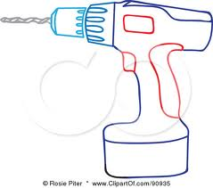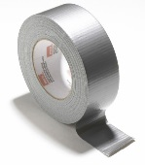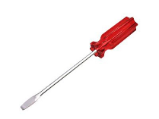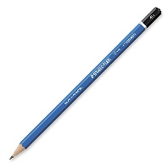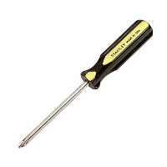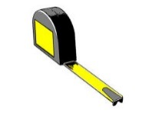

Hammer

Wire stripper

Drill

Tape measure

Above Tools as needed

Ladder

Tape

Flat Blade screwdriver

Pencil

Phillips screwdriver

A

B

C

D

E

## Safety

Refer to SecuRemote Enabled Architectural Mortise Lock Installation Instructions which has been received with it.

## Install SR KEELER

Refer to SecuRemote Enabled Architectural Mortise Lock Installation Instructions which has been received with it.

## SR KEELER detail for different buttons and LED’s

* **LED Indication**
* **Blue** **LED** – Blinks when smartphone is connected to SR KEELER
* **Red** **LED** – Glows as door lock
* **Green LED** – Glows as door unlock

# Symbol Explanations for KEELER

|  |  |
| --- | --- |
|  | The SR Smart App is performing an operation |
|  | Press this button to check the status of the selected device |
|  | The device is in “Unlocked” position |
|  | The device is in “Locked” position |

# 

# SR KEELER Overview

SR KEELER represents a new era of user-friendly security, control and convenience. It will provide many smart features that are not possible with standard conventional door lock. Here is a list of key features that are provided by this SR KEELER.

* 1. Operate SR KEELER using SR Smart application installed in iOS or Android devices. User can operate it within radius of up to 80 feet from SR KEELER without obstacles in Local Mode.
  2. User can operate device from remote location.
  3. User can operate device by Keyfob within 40 feet range of device.
  4. Provide access to other users.
  5. Notification alert, which is triggered if you have forget to lock door and moved a mile away from the SR device location.
  6. Audit trail shows last 255 operations in smartphone with detail about each operation executed by any user.
  7. Configure user PIN so it prompts user to enter PIN every time user operates SR KEELER.
  8. User can upgrade firmware from SR Smart app.
  9. User can manage other user and device access settings from SecuRemote® Portal.

**How it works**

The SecuRemote® Smart app uses unique technology to transparently deliver powerful communication, authentication and functionality. The communication process begins when the primary User pairs his/her smartphone with a SecuRemote® device. The device registers the first users as an “Administrator”.

The Administrator can add 10 users (total of 10 users including Administrator/Keyfob) from his/her smartphone. Each user will receive a text Message with a link to download the App. Users can operate device within range of 80 feet in Local Mode depends on obstacle and Remote Location also.

## Local Mode

In this mode the communication between an SR device and a Smartphone is direct (between the two devices) using Bluetooth. Communication distance can be up to 80 feet depending on communication obstructions or the product application. This mode also supports Administration (Users are stored on the device itself), and Notification within Bluetooth range.

## Remote Mode

This mode offers all the previous benefits, but it also adds the ability for an SR device to be connected to SR online portal all the time, thus allowing a remote operation through SR online portal and event monitoring even when a user’s Smartphone is not present. This mode requires the use of an SR Bridge (Ethernet or CDMA) and an Internet Router with an Ethernet port. The SR Bridge setup and configuration are automatic. The SR Bridge uses Bluetooth to connect automatically with up to 24 SR devices wirelessly and directs the messaging to the SR online portal.

# Download SR Smart App for iOS

The SR Smart App will operate any SR device. Upon selecting the SR device user wants to operate the app will automatically display menu features and functionality for the selected device. The app is available for download through the App Store on your Smartphone. Search for "SecuRemote" or "SR Smart" or “SecuRemote® Smart” word. The user should always download the SR Smart App directly from your smartphone’s store as this practice ensures future automatic app improvements/updates.

***Note:*** Make sure smartphone have the data connectivity to download app.

## Download the SR Smart App through Apple Store

1. Click on “App Store” Icon to open app store. Refer Figure 1.
2. Search “securemote” keyword to find SecuRemote® Smart application. Refer Figure 2.
3. Click on “GET” it will prompt for an Apple ID and password to begin SR Smart application download.

Refer Figure 3.

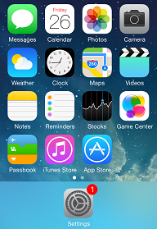 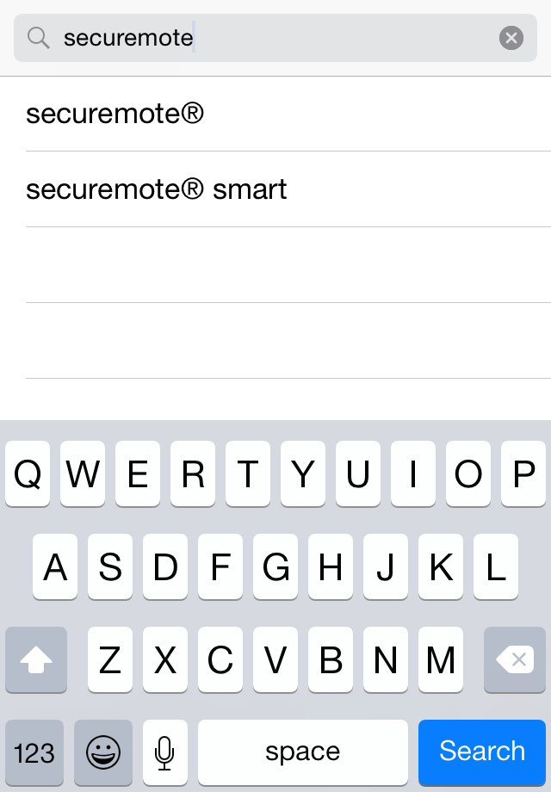 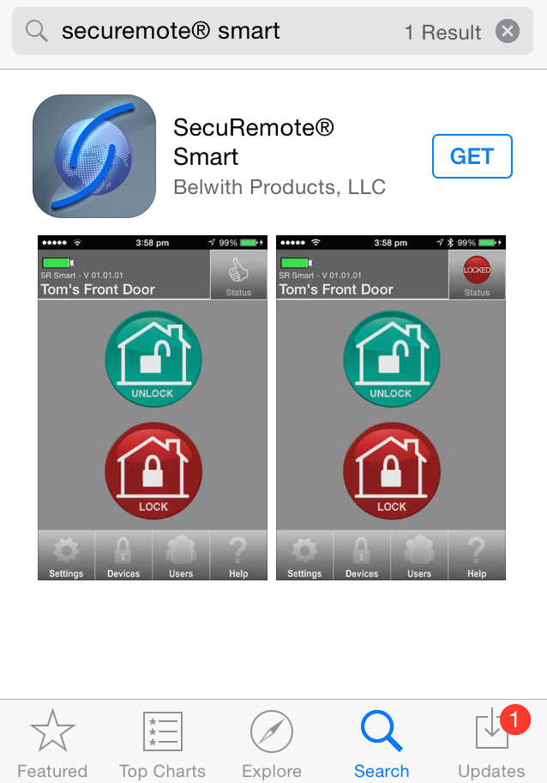

Figure 1: Smartphone Home Screen Figure 2: Search for SR Smart App Figure 3: App store search Screen

1. Click on “INSTALL”, to start installation of SR Smart application. Refer Figure 4.
2. By default, the “SR Smart” App icon will be placed in the first available spot on your home screen.

Refer Figure 5.

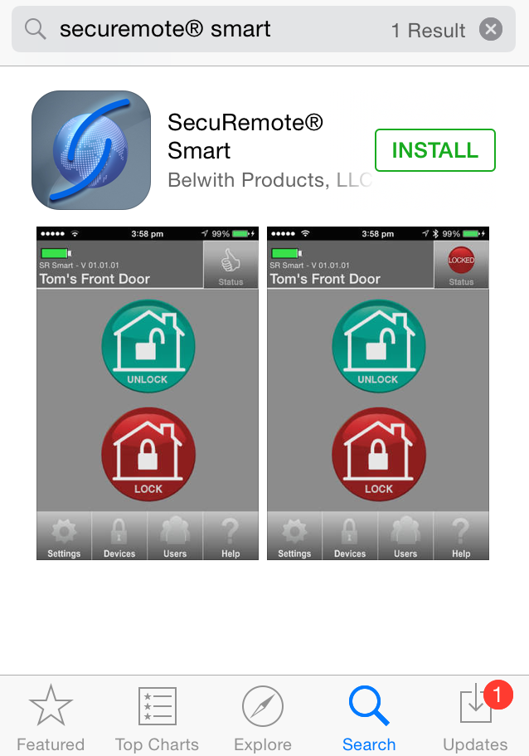 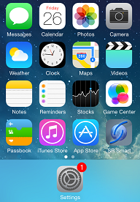

Figure 4: Installation Screen  Figure 5: App Icon in Home Screen

# 

# Download SR Smart app for Android

The SR Smart App will operate any SR device. Upon selecting the SR device user wants to operate the app will automatically display menu features and functionality for the selected device. The app is available for download through the Google Play Store on your Smartphone. Search for "SecuRemote" or "SR Smart" or “SecuRemote® Smart” word. The user should always download the SR Smart App directly from your smartphone store as this practice ensures future automatic app improvements/updates.

***Note:*** Make sure smartphone have the data connectivity to download app.

## Download the SR Smart App through Play Store

1. Click on “Play Store” icon to download SR Smart App. Refer Figure 6
2. Search “securemote” keyword to find SR Smart application. Refer Figure 7.
3. Click on “FREE” to begin SR Smart application download. Refer Figure 8.

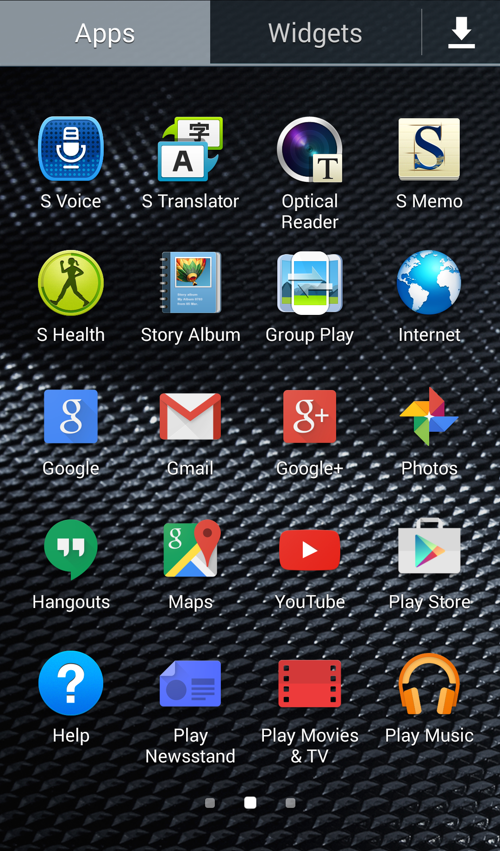 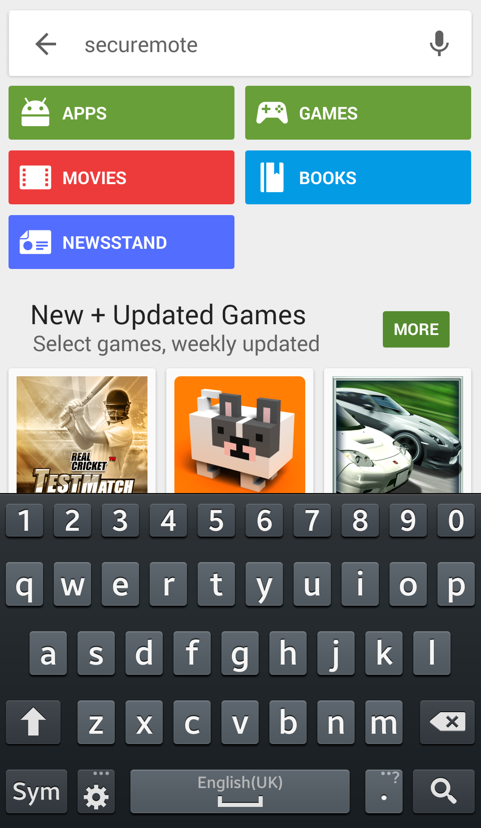 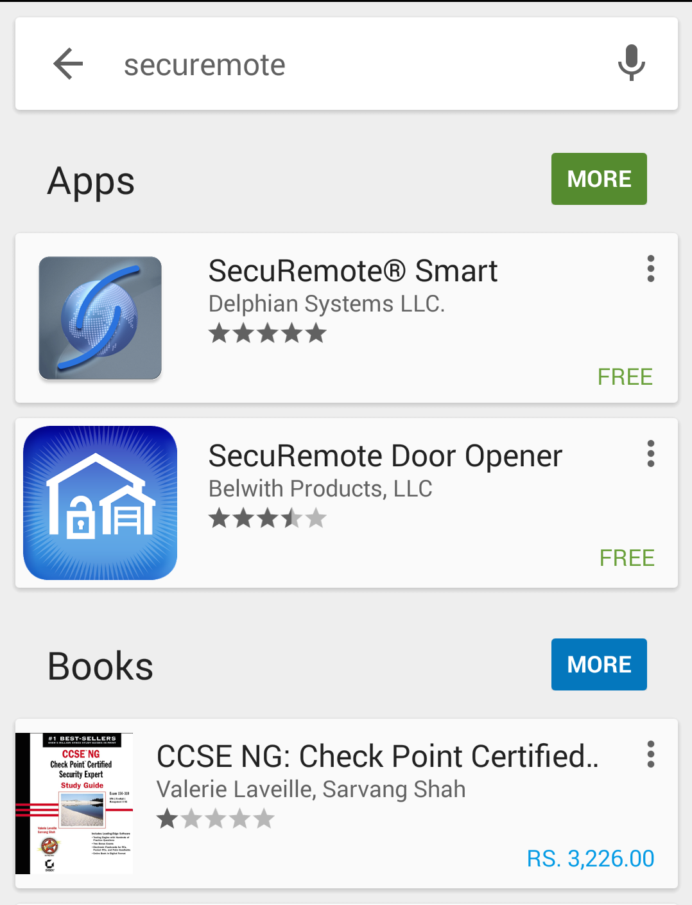

Figure 6: Smartphone Home Screen Figure 7: Search for SR Smart App Figure 8: App store search Screen

1. Click on “INSTALL”, to start installation of SR application. Refer Figure 9.
2. By default, the “SR Smart” App icon is placed in the first available spot on your home screen.

Refer Figure 10.

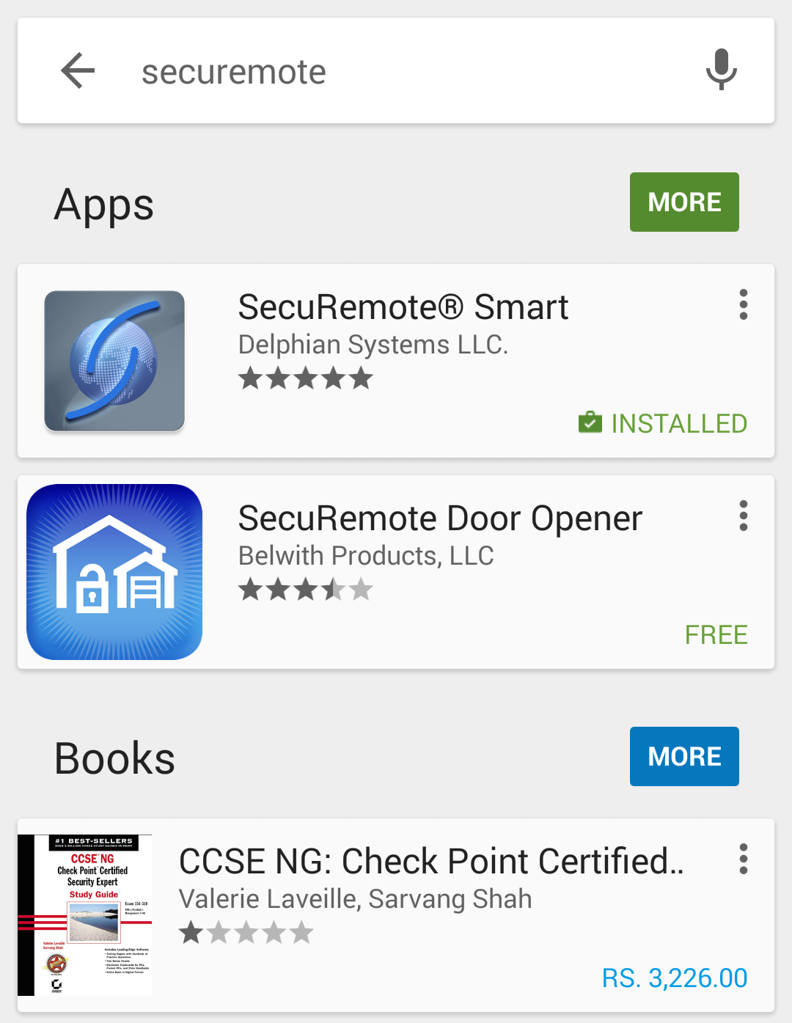 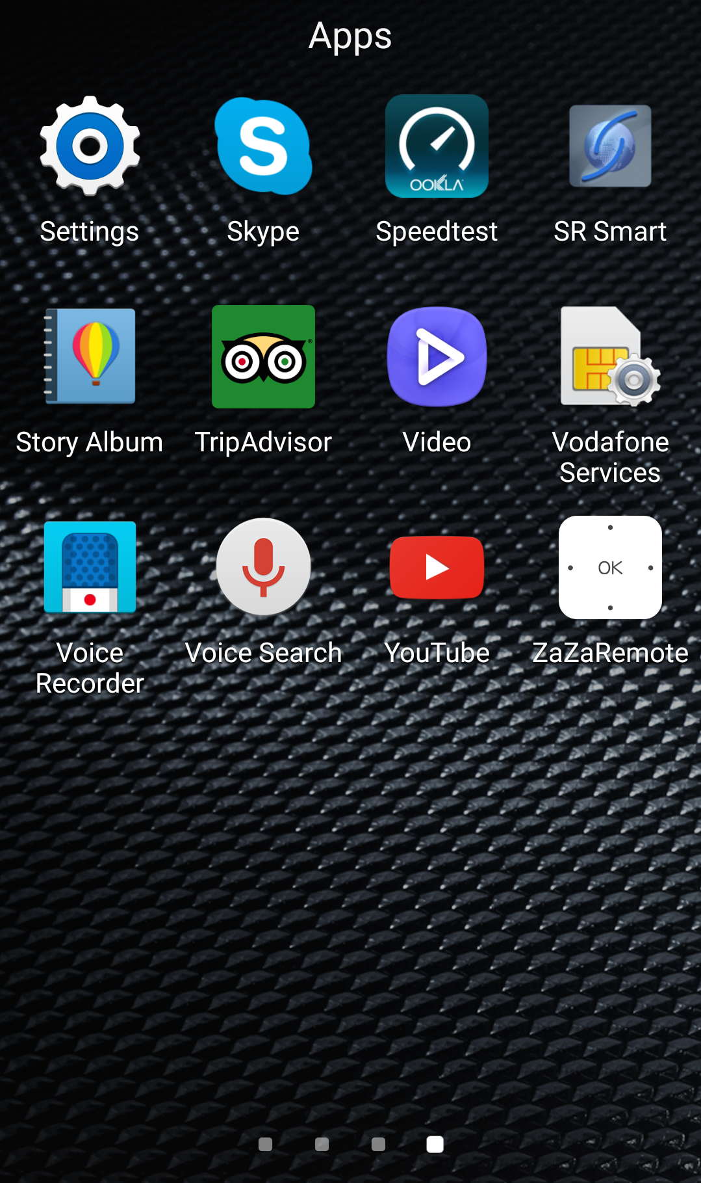

Figure 9: Install SR Smart App Figure 10: Installation Completed

# Register and Operate SR KEELER

After successful installation of “SR Smart” app, SR Smart app icon will appear on smartphone home screen. User can register SR device using “SCAN QR CODE” or “Enter SR # manually” options, upon successful activation user can pair and operate SR KEELER.

***Note:*** Make sure Data & Bluetooth connectivity is “ON”.

## Register Device using Scan “QR Code”

1. Click on the “SR Smart” app icon to launch the SR Smart app. “ADD SR DEVICE” screen will open.

Refer Figure 11.

1. Click on “SCAN QR CODE” option to add device, “Scan QR Code” will launch Camera to scan SR # from user manual or interior part of SR KEELER. Refer Figure 12.
2. After QR Code is scanned successfully, SR Device information fill automatically in “ADD SR DEVICE” screen. Enter “SR Device Name” and click on “Create New Account” option. Refer Figure 13.

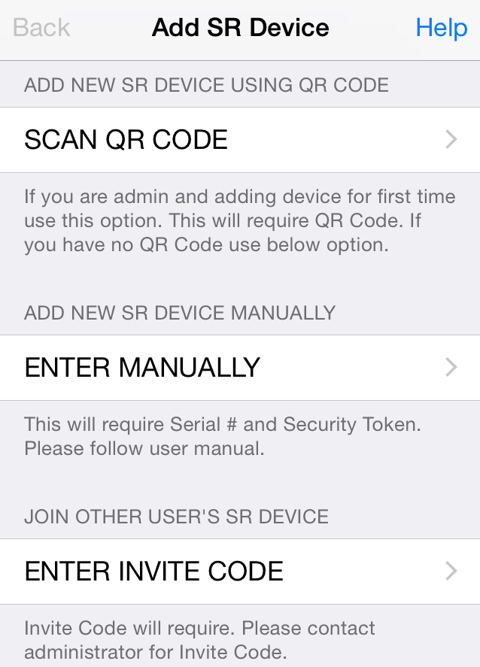 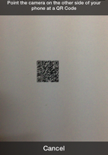 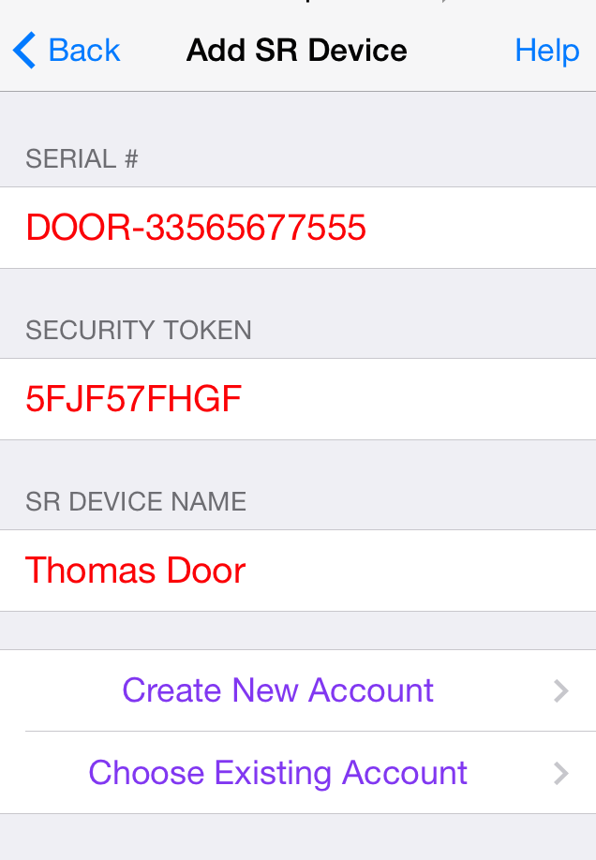

Figure 11: Add SR Device  Figure 12: Scan QR Code  Figure 13: Add SR Device

1. Enter all mandatory information in “Create SR Account” screen and click on “Register SR Device” option. Refer Figure 14.
2. It will display “Registering SR Device” activity message in “Create SR Account” screen. Refer Figure 15.
3. After device is registered on server it will redirect to app home screen and display “Garage is paired successfully, you can start operate it.” Toast message. Refer Figure 16.

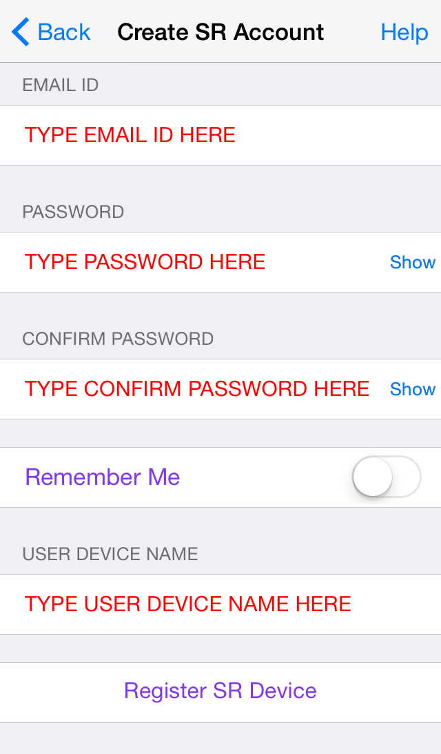 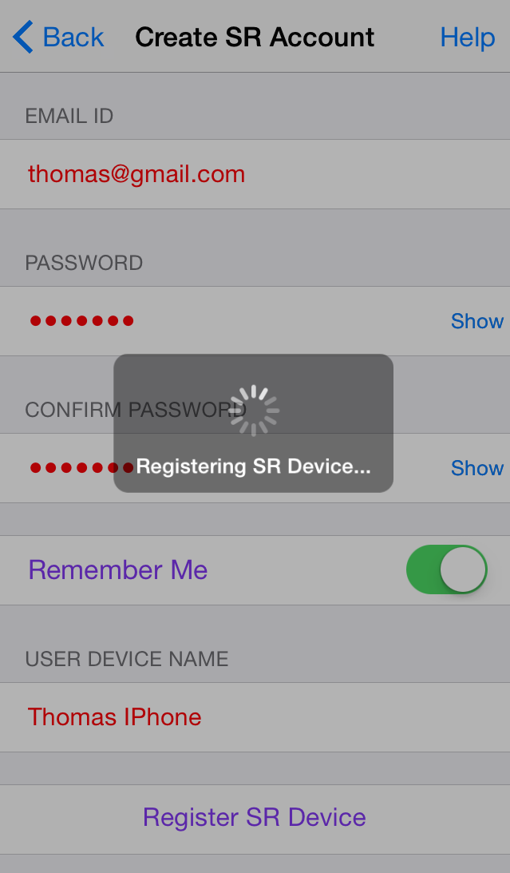 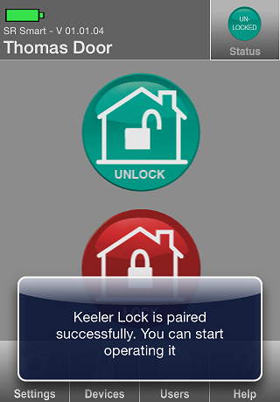

Figure 14: Create SR Account Figure 15: Registering SR Device Figure 16: Home Screen

## Register Device manually

1. Click on the “SR Smart” app icon to launch the SR Smart app. “ADD SR DEVICE” screen will open, Click on “Enter MANUALLY” option to add device manually. Refer Figure 17.
2. It will display “ADD SR DEVICE” screen. Refer Figure 18.
3. Enter all require SR Device information and click on “Create New Account” or “Choose Existing Account” option to add SR Device information. Refer Figure 19.

  

Figure 17: Add SR Device Figure 18: Add SR Device Figure 19: Add SR Device detail

1. It will display “Create SR Account” screen. Refer Figure 20.
2. Enter all require SR Account details and click on “Registering SR Device” option, it will appear “Registering SR Device” activation message. Refer Figure 21.
3. After device is registered on server it will redirect to app home screen and display “Keeler Lock is paired successfully. You can start operate it.” Toast message. Refer Figure 22.

  

Figure 20: Create SR Account Figure 21: Registering SR Device  Figure 22: Home Screen

# Operate SR KEELER using SR Smart App

1. Device Home Screen when device is not connected. Refer Figure 23.
2. Click on the “Lock” button to lock the Door, it will display “Door is Locked” toast message. Refer Figure 24.
3. Click on the “Unlock” button to unlock the Door, it will display “Door is Unlocked” toast message. Refer Figure 25.

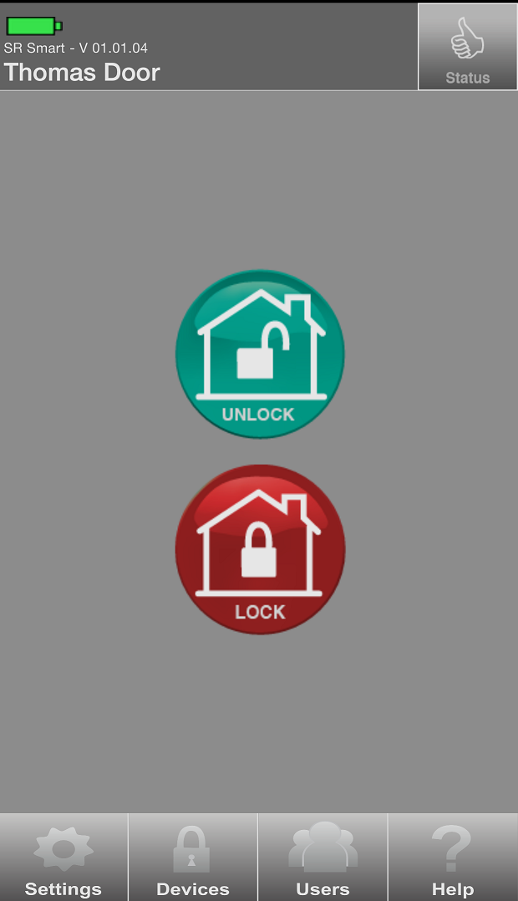 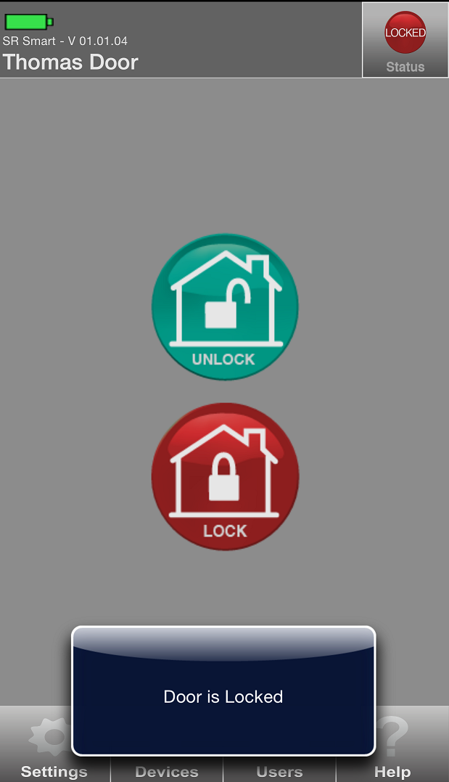 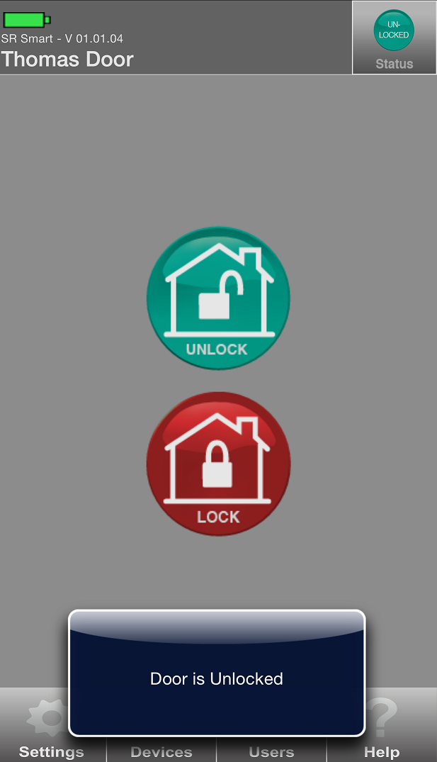

Figure 23: Home Screen Figure 24: Locked Message Figure 25: Unlocked Message

# Check Status of your SR KEELER

1. If the door is Unlocked then “Unlocked” will be indicated in Status. Refer Figure 26.
2. If the door is locked then “Locked” will be indicated in Status.

Refer Unlocked Status Figure 27.

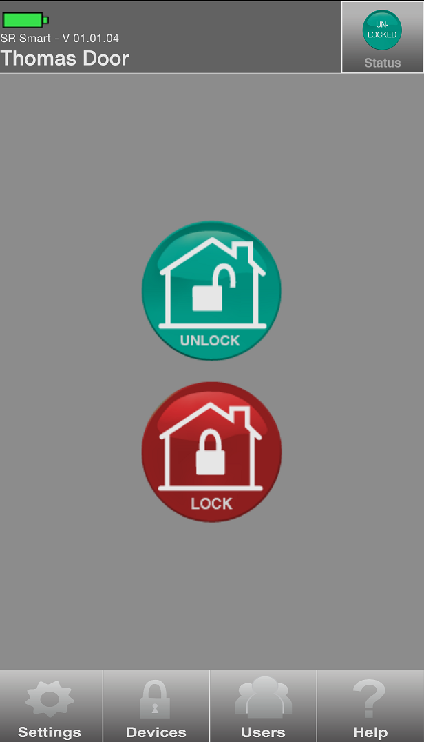 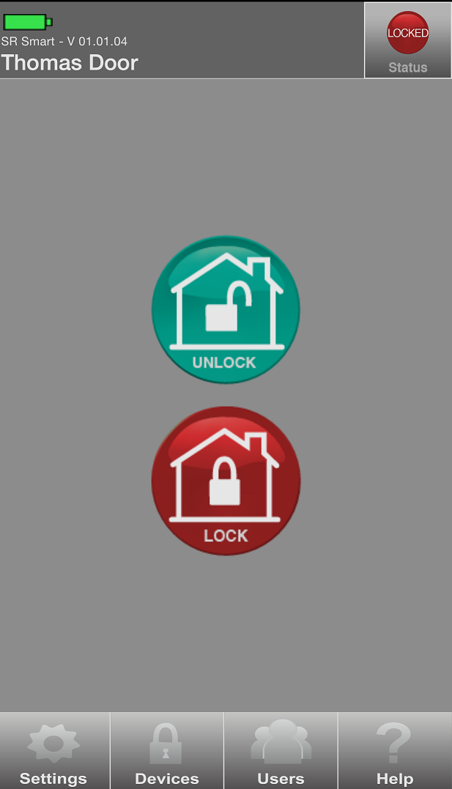

Figure 26:  Unlocked Status Figure 27: Locked Status

# Setting Management

Admin user can set any SR KEELER parameter using this option. Go in “SR Device Settings” from “Settings” option to change settings.

## SR Device Settings

1. Click on “Settings” from Home screen and click on “SR Device Settings” option. Refer Figure 28.
2. It will display “Administrator Details” screen, enter “email id” and “password” of your SR account.

Refer Settings Screen Figure 29.

1. It will display “SR Device Settings” screen. Refer Figure 30.

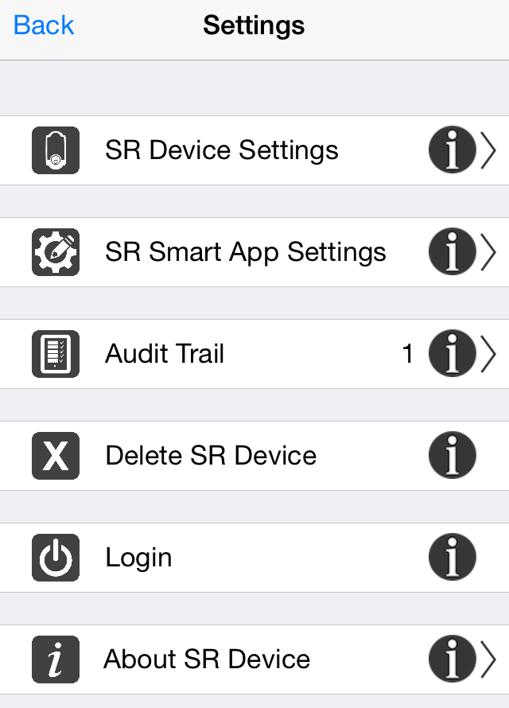 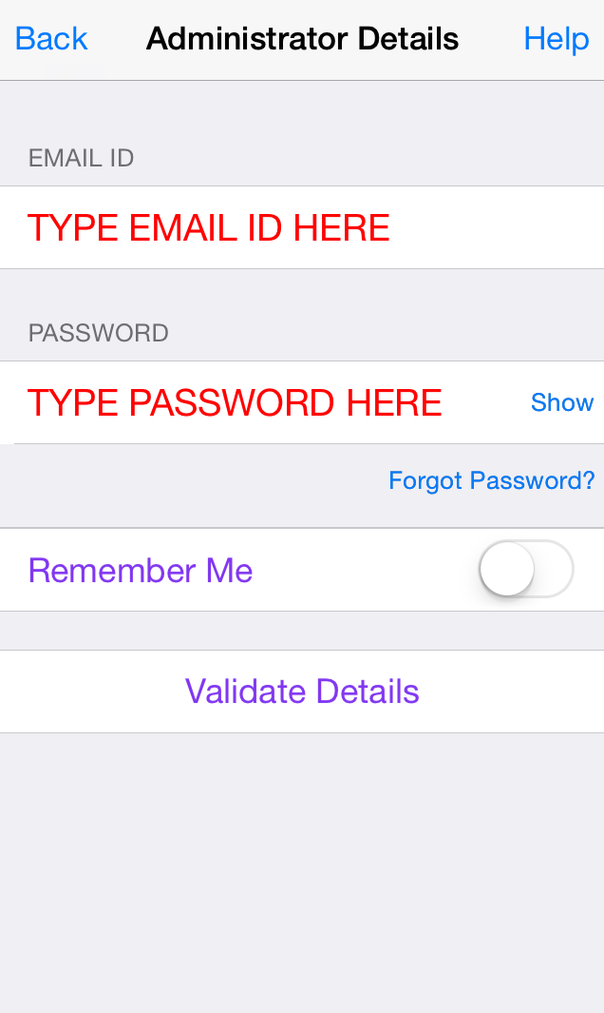 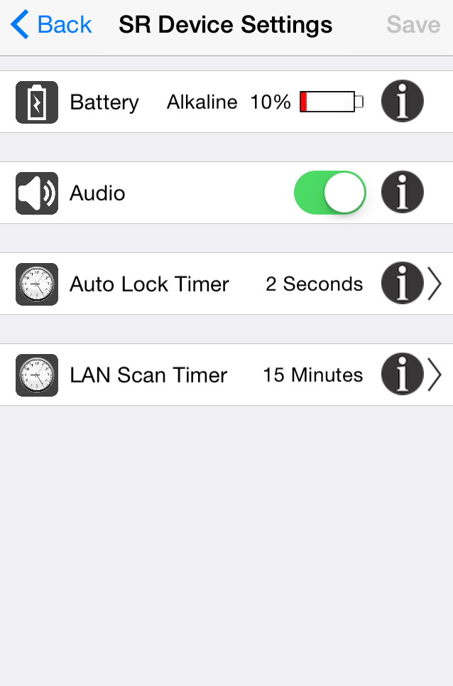

Figure 28:  Settings Screen Figure 29: Admin Validation Figure 30: SR Device Settings

***Note:*** After change all the settings click on “Save” option to change settings. If you are having Keeler 3.0 model then Audio and LAN Scan Timer settings will not be displayed. Audio feature is given in mobile device for 3.0 and above versions.

## Battery

1. Click on “Settings” from Home screen and current “Battery” information of keeler device display in first option of “SR Device Settings” screen. Refer Figure 31



**Figure 31: Battery Information**

## Audio

In addition to light indicators Keeler locks are equipped with sound or audio that announces an operation.

This feature is used to turn the audio on/off.

1. Use the toggle button to turn “Audio” on/off, select second option of “SR Device Setting” screen”.

Refer Figure 32.

2. Click on “SAVE” option. Refer Figure 33.

3. “SR Device Settings is changed successfully” Confirmation toast message will display. Refer Figure 34.

  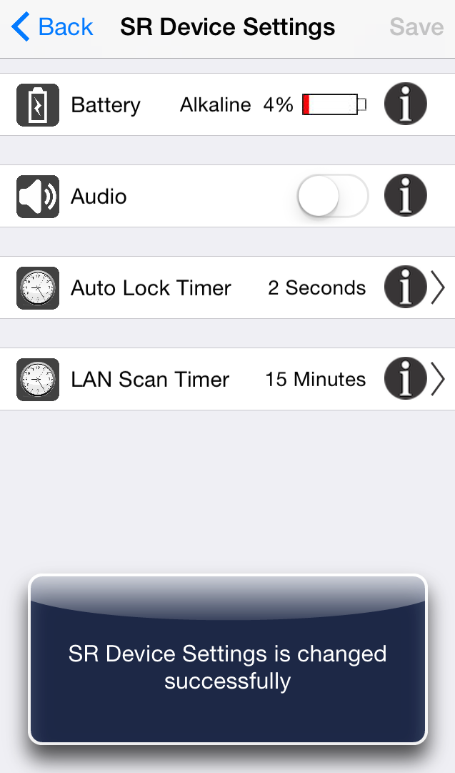

**Figure 32: Settings** **Figure 33: SR Device Settings** **Figure 34: Confirmation Message**

## Auto Lock Timer

1. Click on “Auto Lock Timer” from “SR Device Setting” screen. Refer Figure 35.

2. Select desired time to auto lock keeler device. Refer Figure **36**.

3. Click on “SAVE” option.

4. “SR Device Settings is changed successfully” confirmation toast message will display. Refer Figure **37**.

 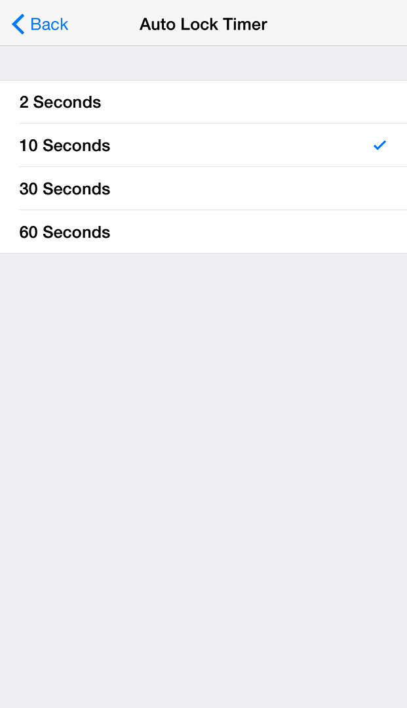 

**Figure 35: SR Device Settings**  **Figure 36: Auto Lock Timer**  **Figure 37: Confirmation Message**

## LAN Scan Timer

This option allows user to specify the local area network scan interval time. SR Device will stop its scanning within Protocol layer/Master Device after this much of time and will go in sleep mode. This feature will help to increase battery life of your SR device by not doing unnecessary scanning.

1. Click on “LAN Scan Timer” screen from “SR Device Settings”. Refer Figure 38.
2. Choose time “LAN scan time” from given time option. Refer Figure 39.
3. Click on “SAVE” option.
4. “SR Device Settings is changed successfully” confirmation toast message will display. Refer Figure 40.

 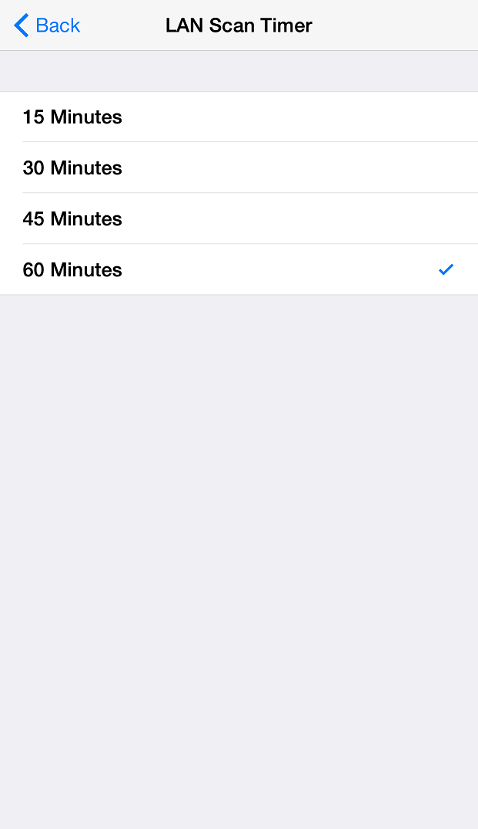 

**Figure 38: SR Device Settings**  **Figure 39: LAN Scan Timer**  **Figure 40: Confirmation Message**

## SR Smart App Settings

## SR Device Name

1. Click on “SR Device Name” from “SR Smart App Settings” option. Refer Figure 41.
2. Enter the desired device name and click on “SAVE” option. Refer Figure 42.
3. It will redirect to “SR Smart App Settings” screen. Refer Figure 43.

 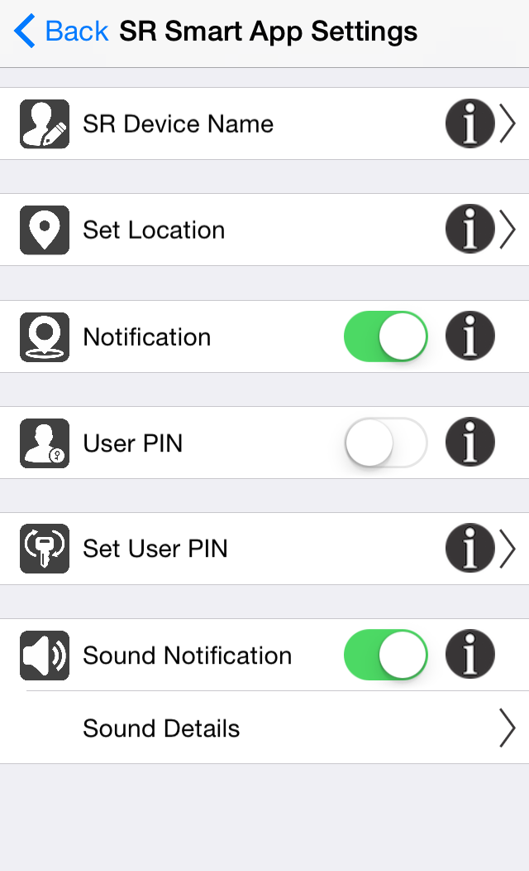 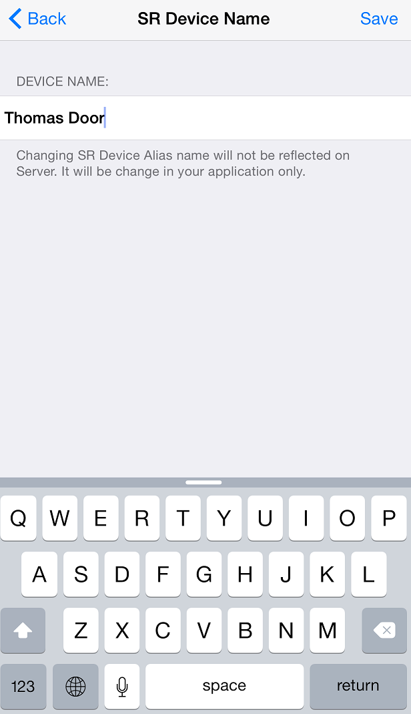

Figure 41: Settings  Figure 42: SR Smart App Settings  Figure 43: SR Device Name

## Set Location

This feature is used to set the Current Location of your SR KEELER, which is necessary to enable “Notification” feature of SR KEELER.

1. Click on “Set Location” option and make sure your smartphone is at a location closest to the SR KEELER. Refer Figure 44.
2. It will pop up one message to ensure that you are at the SR Device location. Refer Figure 45.
3. Set Location Message will pop up with “cancel” and “Set Location” options, Click on “Set Location”. Refer Figure 46.

 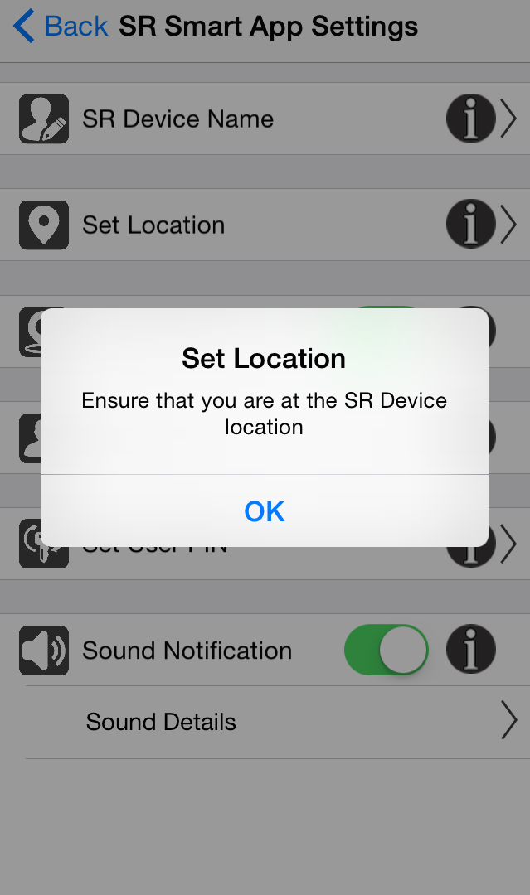 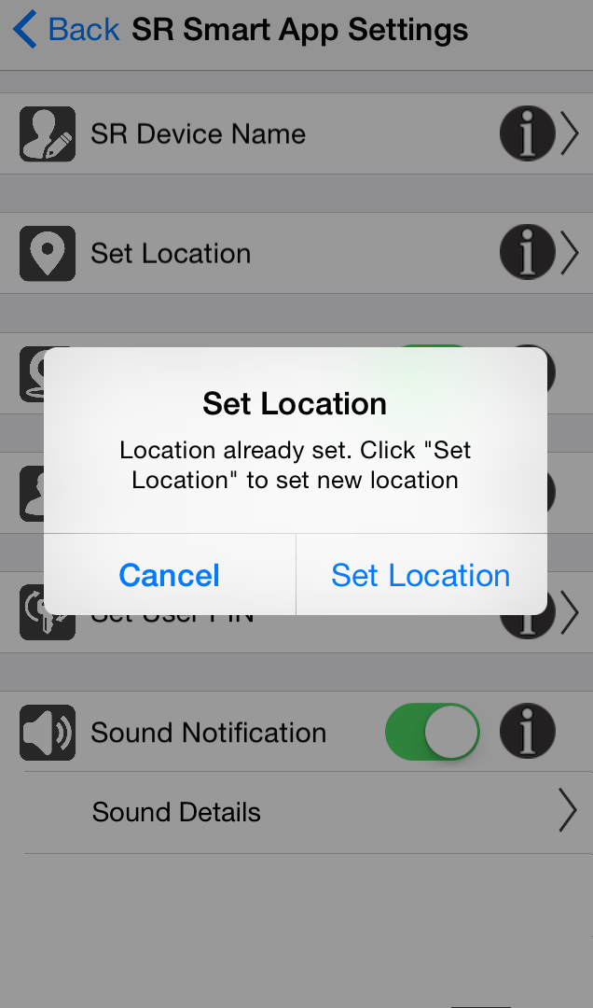

Figure 44: SR Device Settings Figure 45: Location Settings Screen Figure 46: Set Location Message

1. It will display “fetching current location” message. Refer Figure 47.
2. It will display “Device Location is set successfully. Region monitoring is enabled” message with “OK” Button. Refer Figure 48.

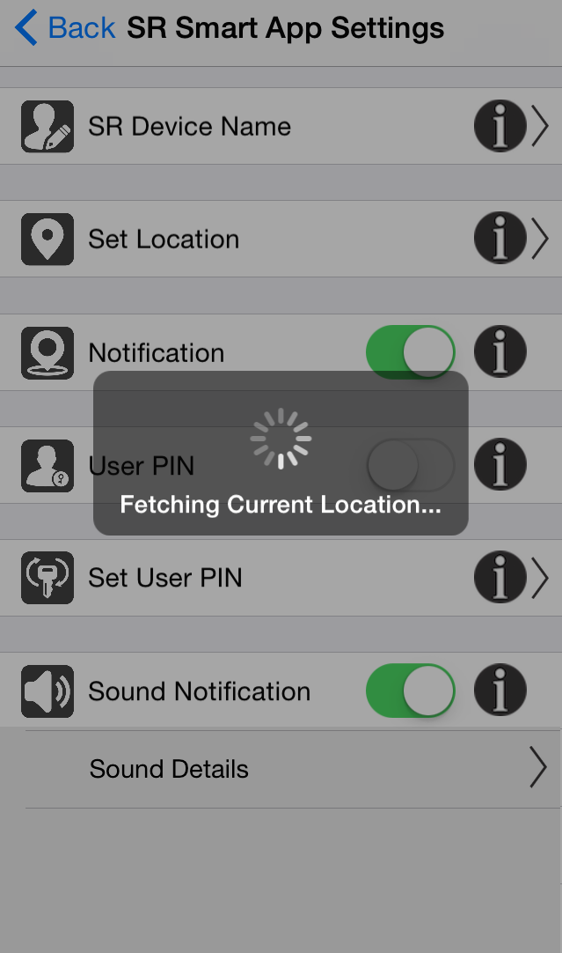 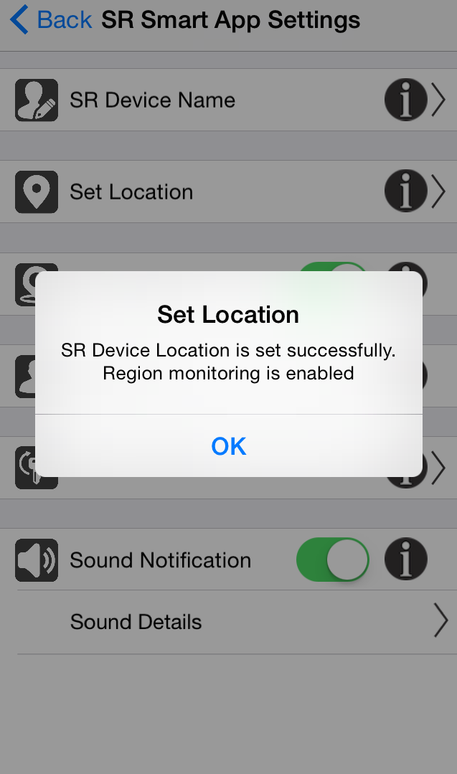

Figure 47: Location Settings Message  Figure 48: Set Location Message

## Notification

Notification alert will be triggered if you forgot to close the door and moved a mile away from the SR device location. This will be accomplished using SR tracking for both your SR device current status and your approximate location by using your smartphone's Location Services.

1. Click on SR Smart App Settings it will display SR Smart App Settings screen. Refer Figure 49
2. Enable/Disable “Notification” by using toggle button. Refer Figure 50
3. Notification message will display in smartphone notification screen. Refer Figure 51

  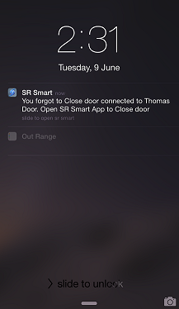

Figure 49: Settings  Figure 50: SR Smart App Settings Figure 51: Notification

## User PIN

Configure user PIN so it prompts user to enter PIN every time user operates SR KEELER.

This feature is used to Enable/Disable User Pin.

1. Click on SR Smart App Settings it will display SR Smart App Settings screen. Refer Figure 52.
2. Enable/Disable “User PIN” by using toggle button. Refer Figure 53.

 

**Figure 52: SR Device Settings**  **Figure 53: SR Device Settings**

## Set User PIN

This option allows the user to change the User PIN. The User PIN is a minimum of four alphanumeric characters and provides additional security. If enabled, the User PIN must be entered every time when user initiates the lock or unlock operation.

1. Click on “Set User PIN” from SR Smart App Settings screen. Refer Figure 54.
2. It will prompt existing “User PIN”; enter default “1234” as User PIN. Refer Smart App Settings Figure 55.
3. User PIN screen will display. Refer Figure 56

 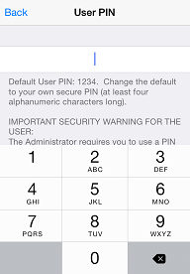 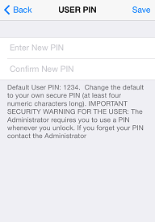

Figure 54: SR Smart App Settings Figure 55: USER PIN Figure 56: USER PIN

1. Enter “New PIN”, “Confirm New PIN” and click on “Save” button. Refer Figure 57
2. It will display “User PIN changed successfully” message. Refer Figure 58

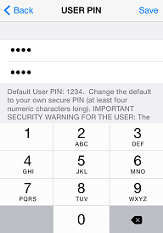 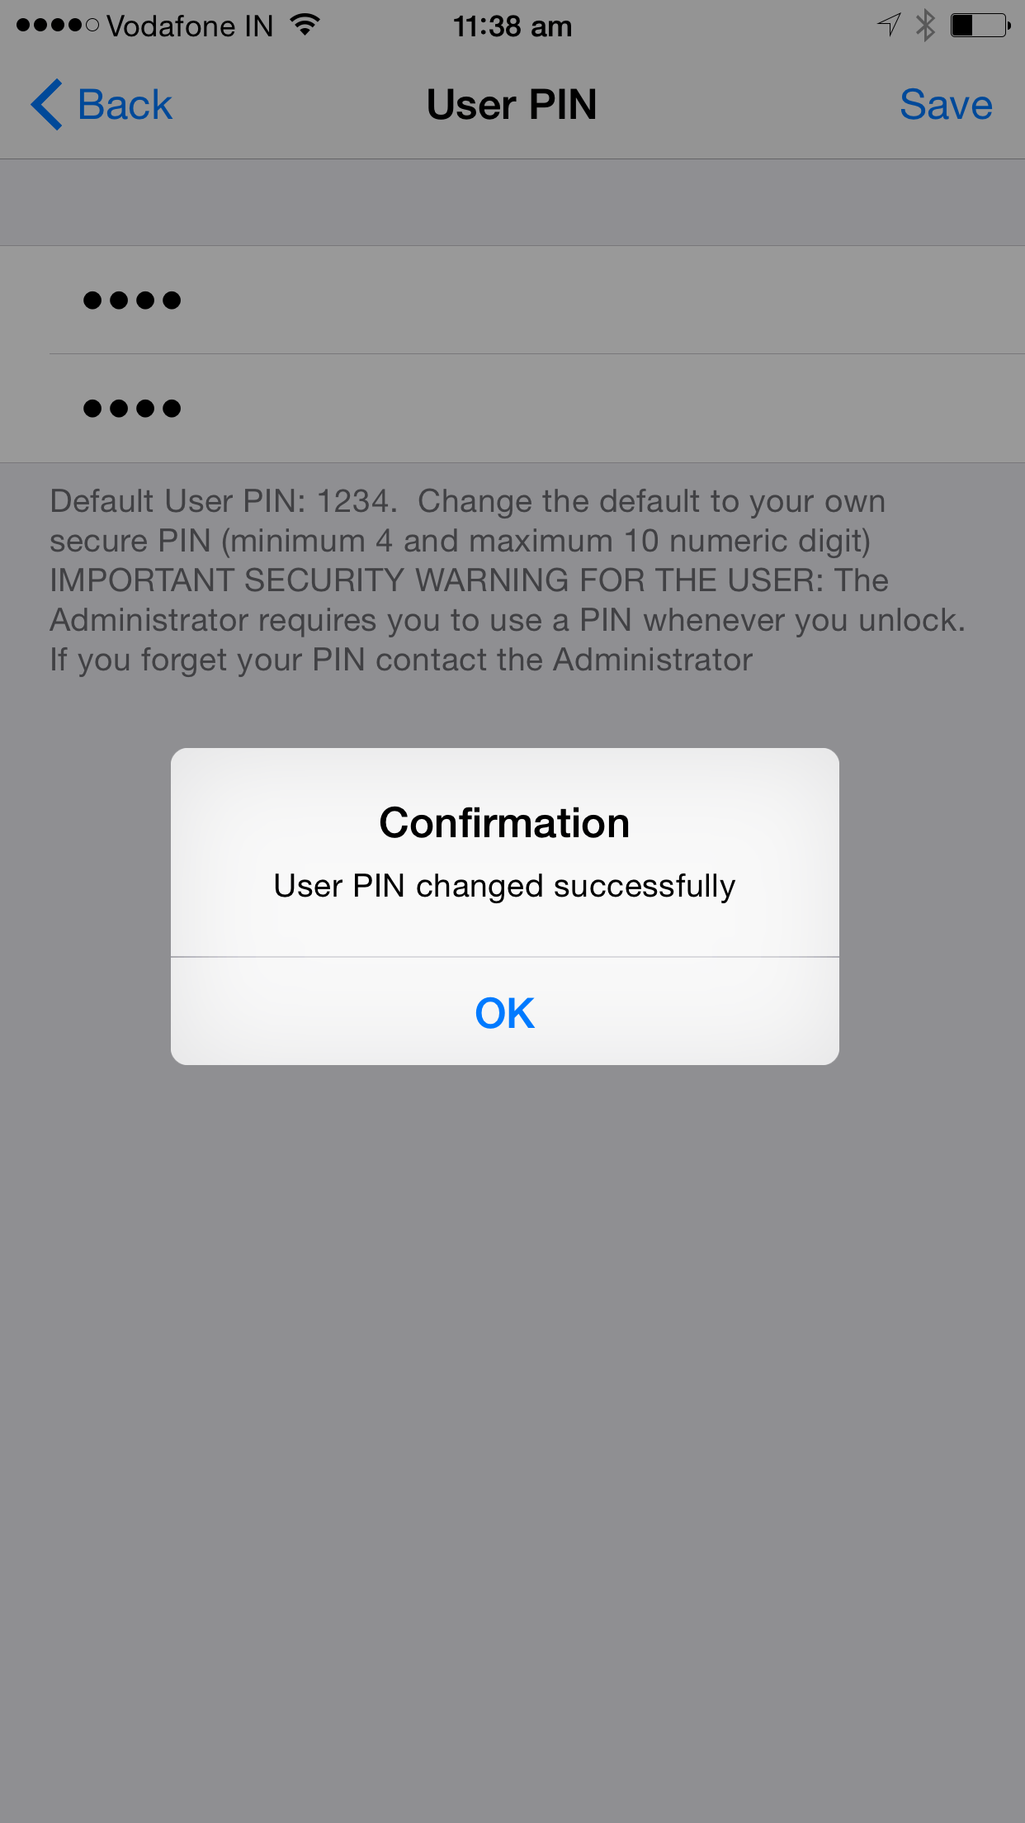

Figure 57: USER PIN Figure 58: Success Message

*Note:* In order to change User PIN, user must know current User PIN. Default User Pin is “1234”. User PIN is stored to smartphone so each user can set any User PIN. If the user forgets the User Pin, user needs to reinstall the SecuRemote® Smart Application.

## Sound Notification

The SecuRemote® Smart Application plays different sounds upon Connecting, Disconnecting and any failure event. User can enable/disable this setting.

This feature is used to Enable/Disable Sound Notification.

1. Click on SR Smart App Settings it will display SR Smart App Settings screen. Refer Figure 59.
2. Enable/Disable “Sound Notification” by using toggle button.



Figure 59: SR Smart App Settings

## Sound Details

The SecuRemote® Smart Application plays different sounds upon Connecting, Disconnecting and any failure event. The App plays sounds for different operations like lock, unlock etc.

This is listing of various sounds played by application while performing different operations. You can click on each sound and check which sounds to be played.

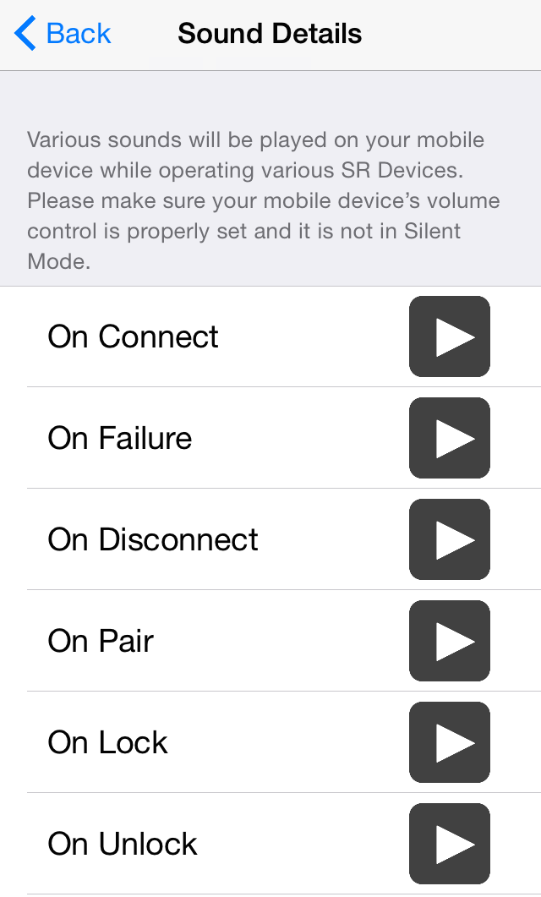

## Audit Trail

This option records and displays the last 255 operations performed.

Each entry has following details:

* Time, Date and Day
* Type
* Status
* User Name

1. Click on “Audit Trail” option from “Settings”. Refer Figure 60.
2. All the local mode operation will display in “Audit Trail” screen. Refer Figure 61.

 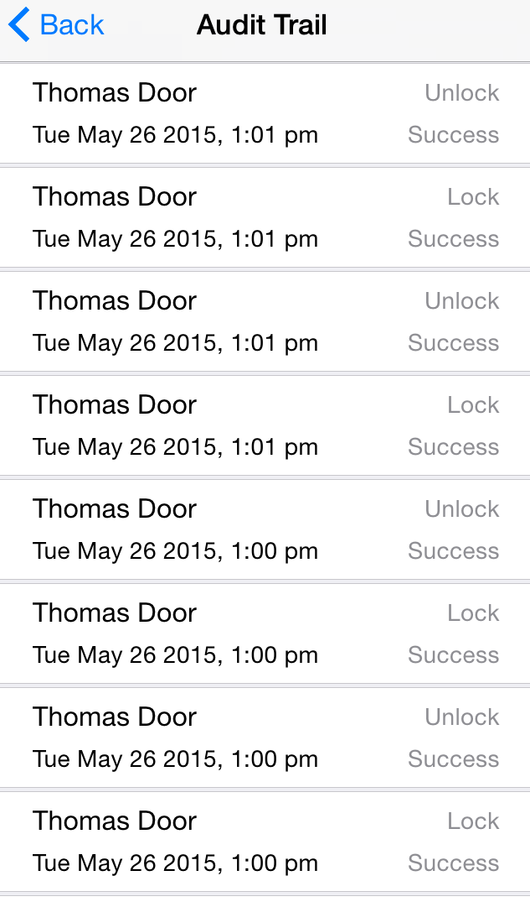

Figure 60: Settings  Figure 61: Audit Trail

*Note:* For operations performed via the Smart Button or Keyfob, the Time, Date and Day will not be available. “Keyfob” will display as User name.

## Login

This option is used for user to login once for their SR account. SR Smart App will not ask admin details again if user has enabled “Remember Me” option. User also can log out using this option. This button will be converted to “Logout” option once user is logged in once.

1. Refer Figure 62 for Login.
2. Refer Figure 63 for Logout.

 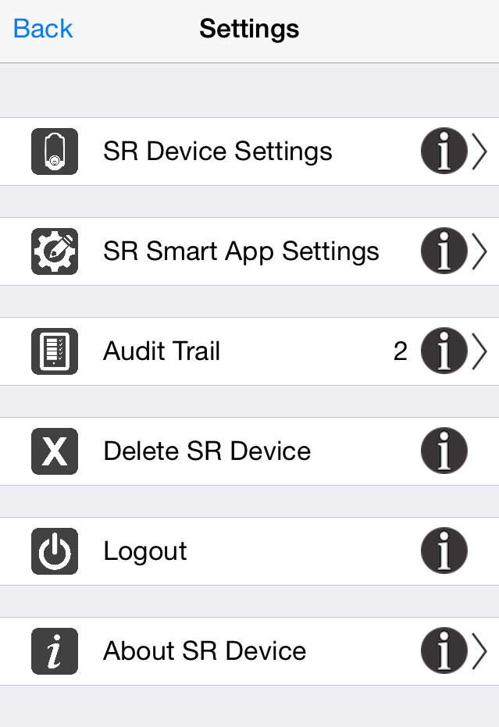

Figure 62: Login Figure 63: Logout

## About SR Device

It provides details on Serial Number, Manufacturer’s Name, Model Number, Hardware Version and Software Version of the SR KEELER.

1. Click on “Settings” from Home screen and click on “About SR Device”. Refer Figure 64.
2. It will open “About SR Device” Screen with SR KEELER details. Refer Figure 65.

 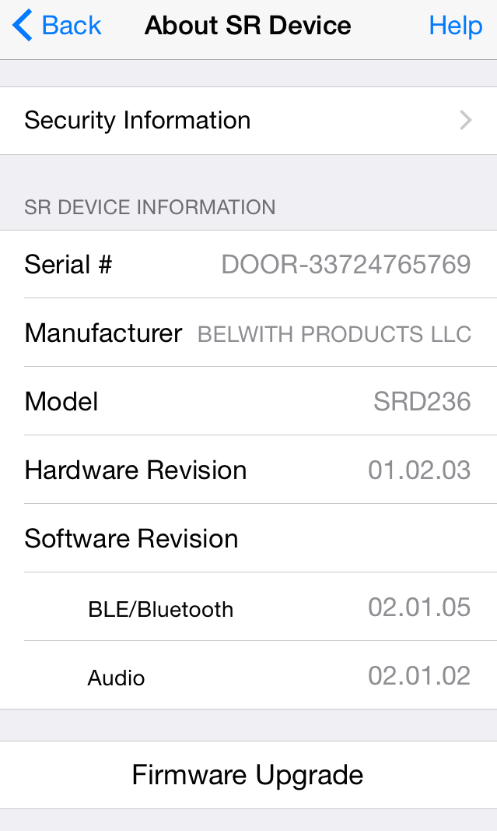

Figure 64: Settings Screen  Figure 65: About SR Device

## Firmware Upgrade

Using this feature user can upgrade Firmware from SR Smart App over the air (OTA).

1. Click on “Settings” from Home screen and click on “About SR Device” option. Refer Figure 66.
2. It will display Administrator Details” screen, enter “email id” and “password” of your SR account. Refer Figure 67.
3. It will display “Firmware Upgrade is in progress…” Refer Figure 68.

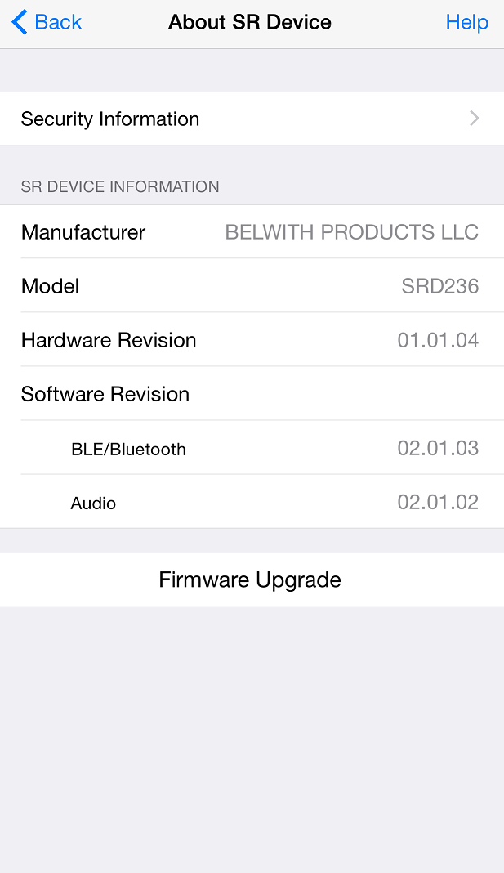  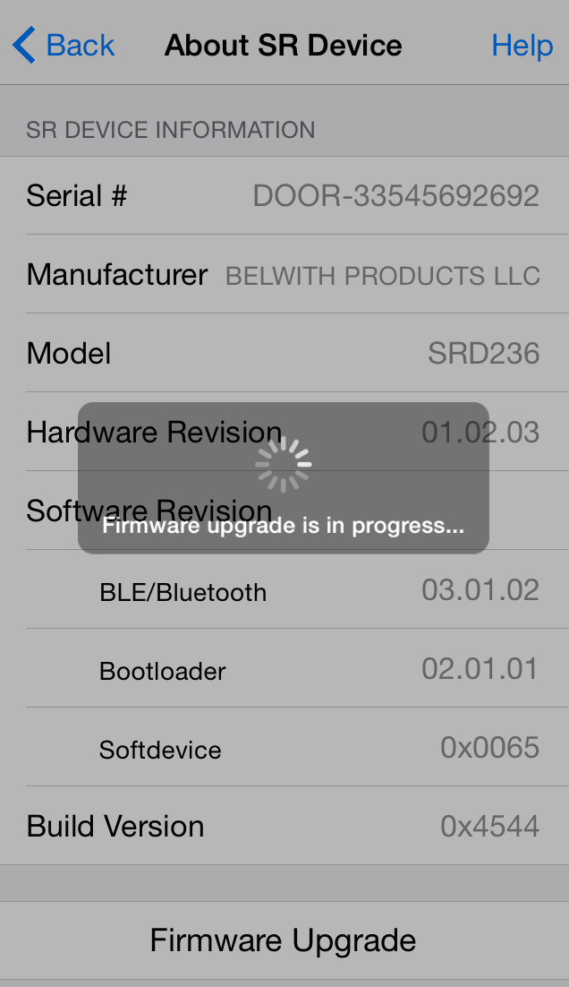

Figure 66: About SR Device Screen Figure 67: Admin Validation Figure 68: Firmware Upgrade Message

1. It will search SR Device for firmware update. Refer Figure 69.
2. After getting searched, SR Device is ready to upload new firmware. Refer Figure 70.
3. It will automatically start firmware upgrade. Refer Figure 71.

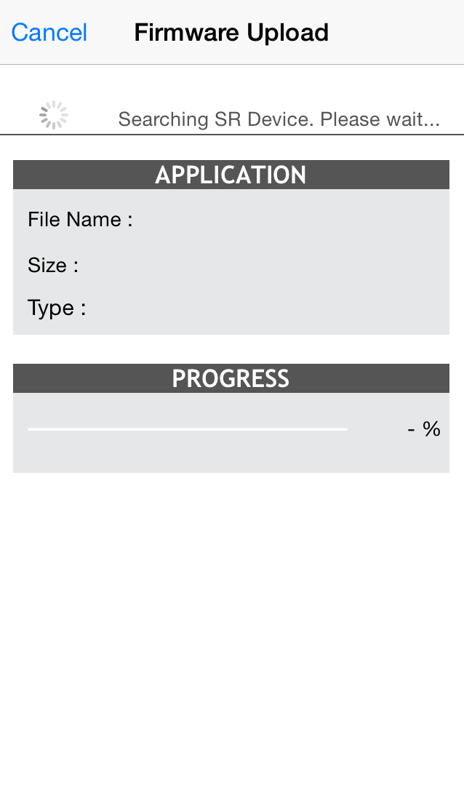 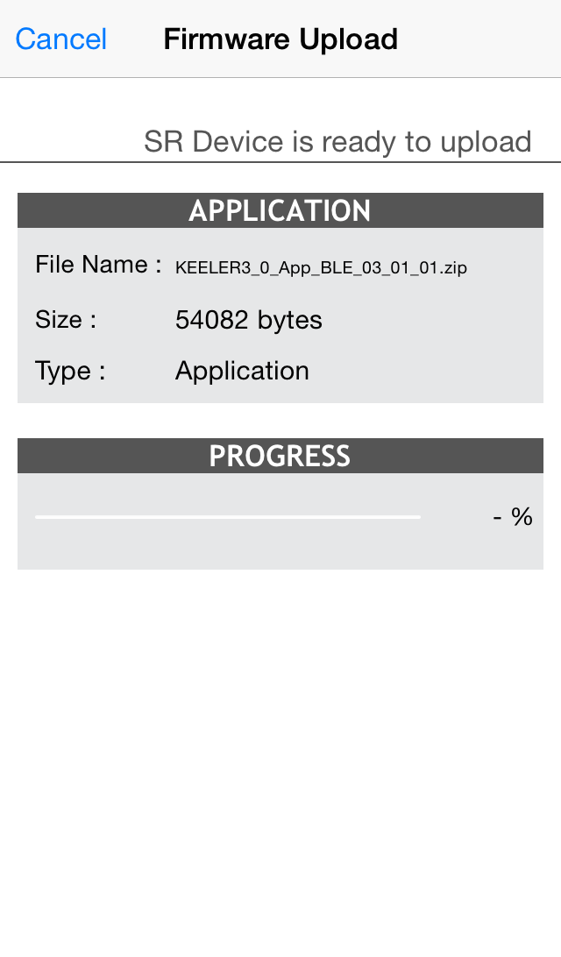 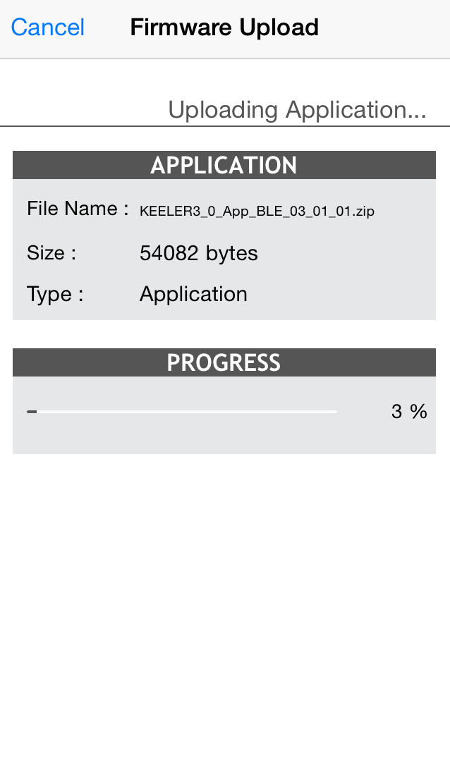

Figure 69: Search SR Device Figure 70: SR Device is ready  Figure 71: Uploading New Firmware

1. Wait for Complete 100% progress bar. Refer Figure 72.
2. Firmware “Finished upload” message will be displayed with “OK” button. Refer Figure 73.

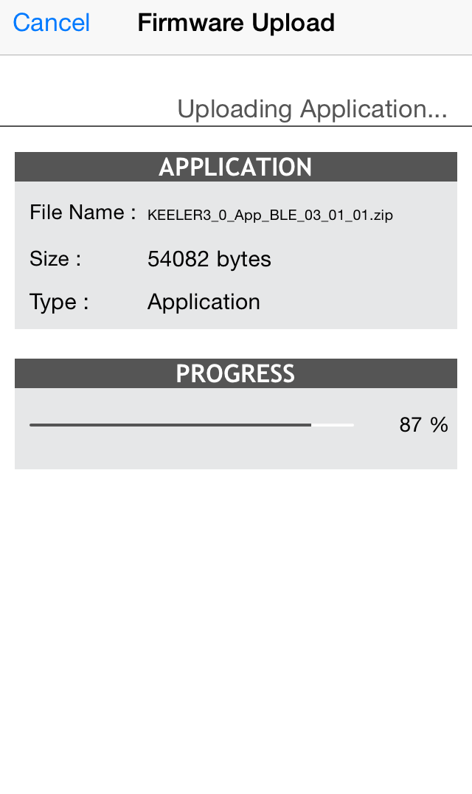 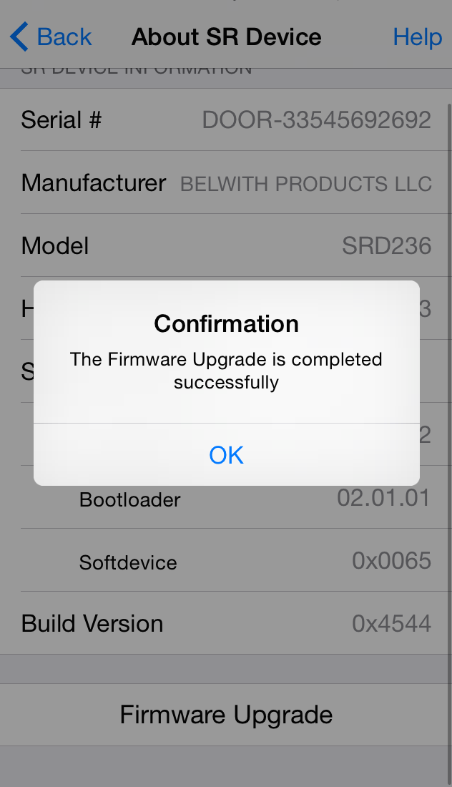

Figure 72: Uploading Firmware Figure 73: Finished Uploaded Message

# Device Management

The user can click on “Devices” option from SR Smart App Home Screen to display, add, delete, rename or check status of all installed SR KEELER controlled by this iOS/Android device.

## Add Device

To add new SR device user can use this option.

1. Select Devices option from Home Screen. Refer Figure 74.
2. Click on Add SR Device to add new device. Refer Figure 75.
3. In Add SR Device user can add device using available options. Refer Figure 76.

 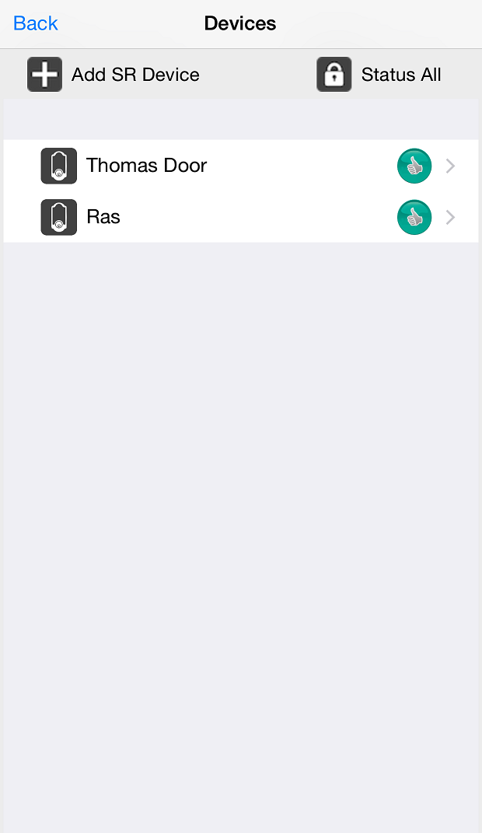 

**Figure 74:** **Home Screen** **Figure 75: Device Screen** **Figure 76: Add Device Screen**

## Rename Device

In this option use can change SR Device name.

1. From Home Screen select existing name of the device. Refer Figure 77.
2. It will redirect to SR Device Name screen and provide new name. Refer Figure 78.
3. Click on “Save” button and it will change new name. Refer Figure 79.

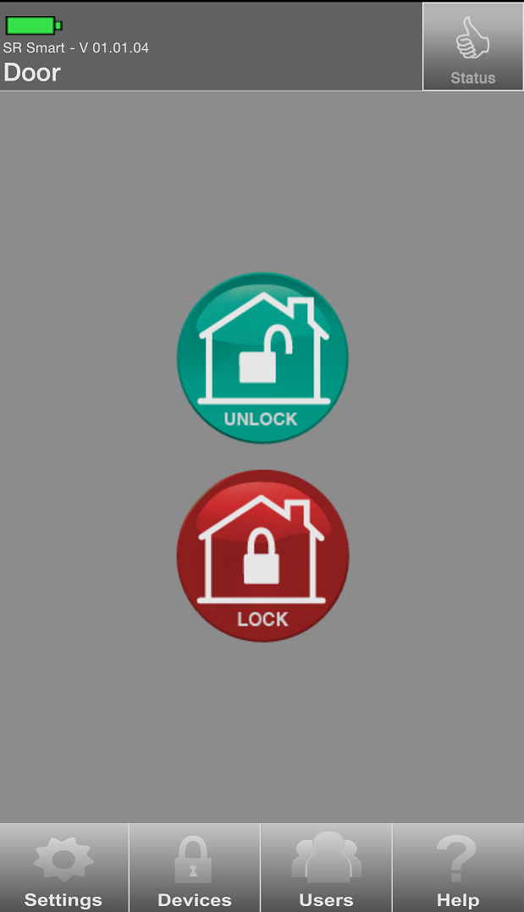 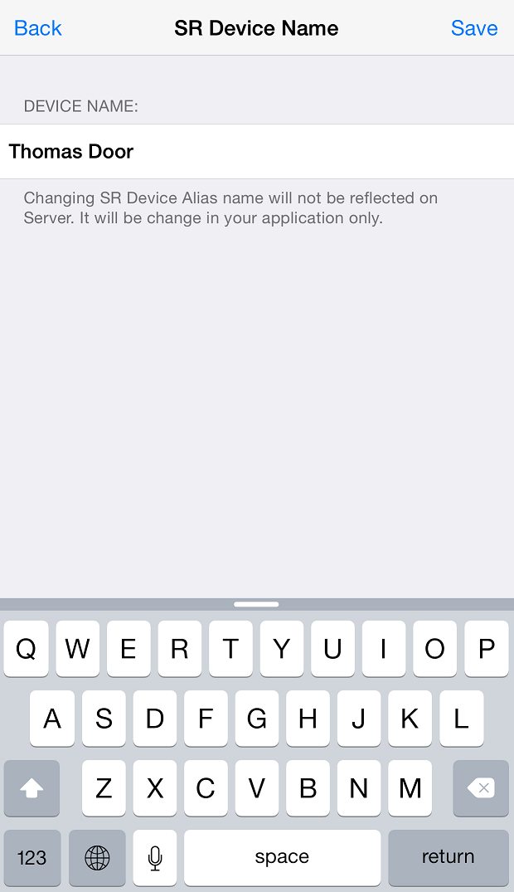 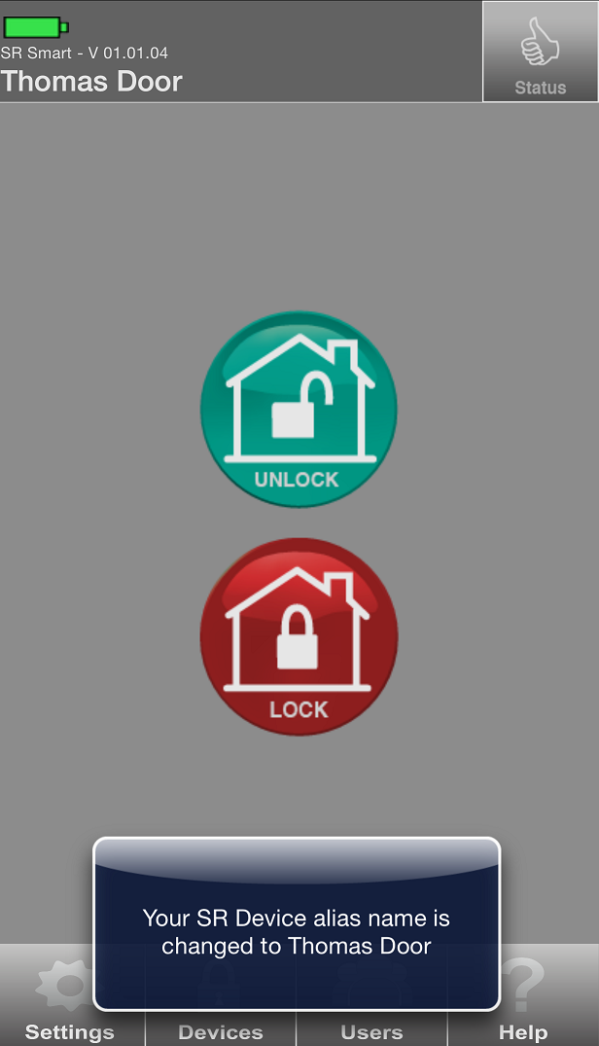

**Figure 77: Home Screen** **Figure 78: SR Device Name Screen** **Figure 79: Name Changed Screen**

## Delete Device

The Admin user only can delete any SR KEELER Device by clicking on “Delete SR Device” option from “Settings” screen. Click on “Delete SR Device” button to delete that device. Confirm the action by clicking on Yes to complete the process:

1. Click on Settings from home screen. Refer Figure 80.
2. Click on Delete SR Device. Refer Figure 81.
3. It will ask user to enter Administrator Details. Refer Figure 82.

  

**Figure 80: Home Screen** **Figure 81: Settings Screen** **Figure 82: Administrator Details**

1. Enter Proper Details and click on Validate Details screen. Refer Figure 83.
2. It shows Removing SR Device. Refer Figure 84.
3. After Removing SR Device it will redirect to Add SR Device Screen. Refer Figure 85.

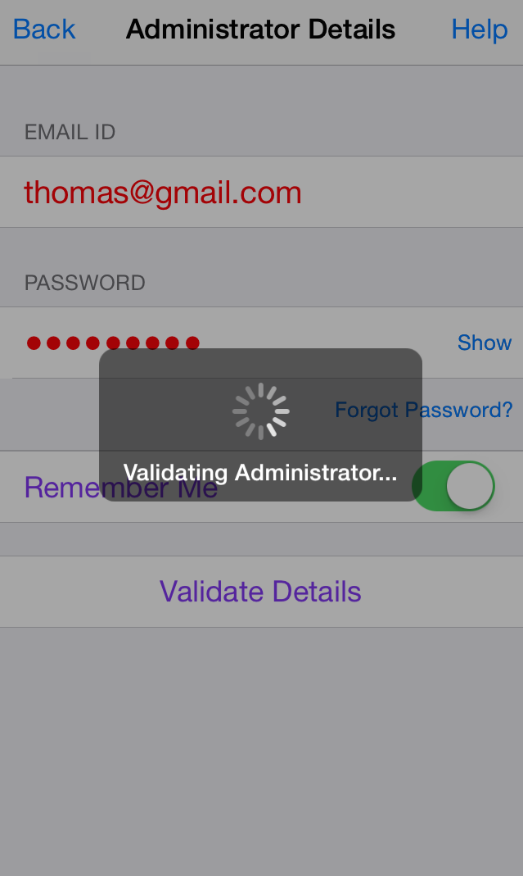 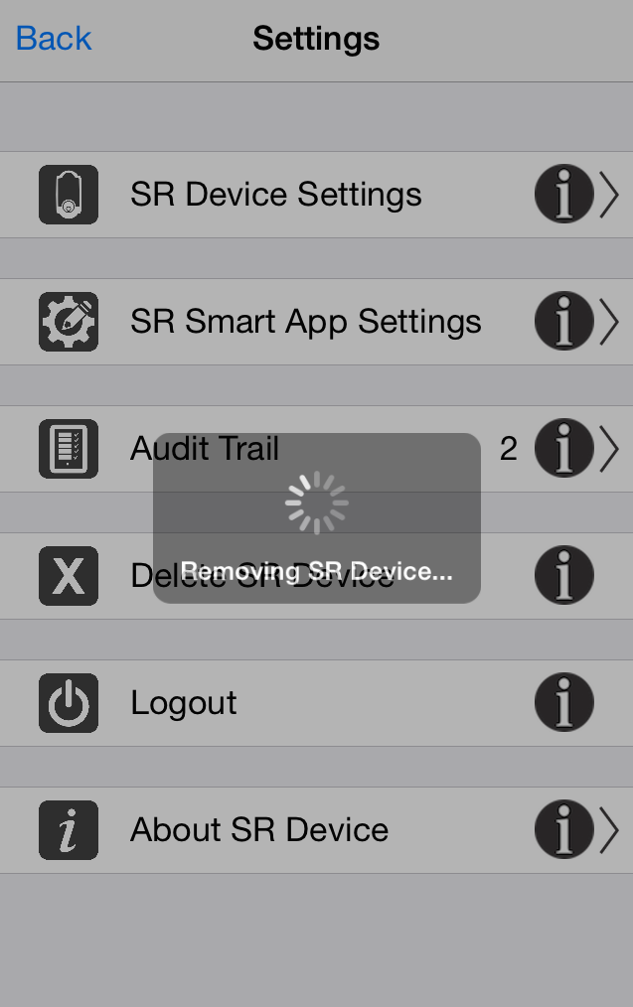 

**Figure 83: Administrator Details** **Figure 84: Removing SR Device** **Figure 85: Add SR Device Screen**

## Status All

This option lets user retrieve the current status of all connected SR Devices managed by this application.

1. Click on Devices Screen. Refer Figure 86.
2. Click on Status All. Refer Figure 87.
3. It will show status of all devices. Refer Figure 88.

 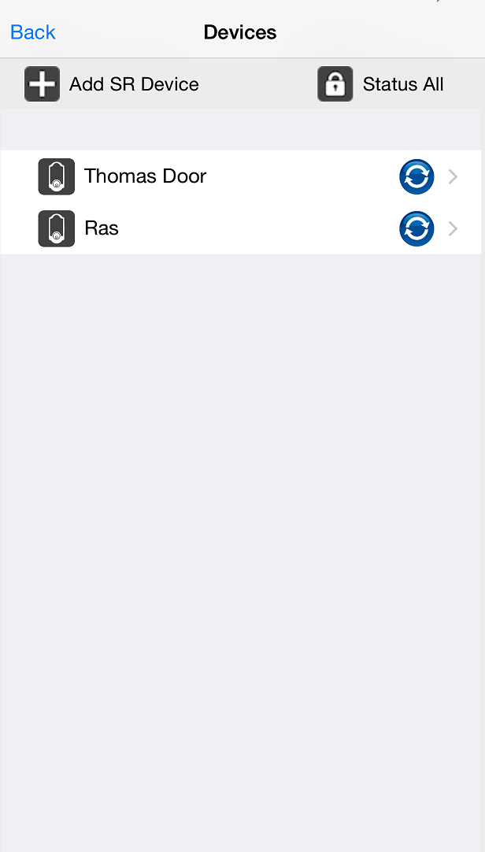 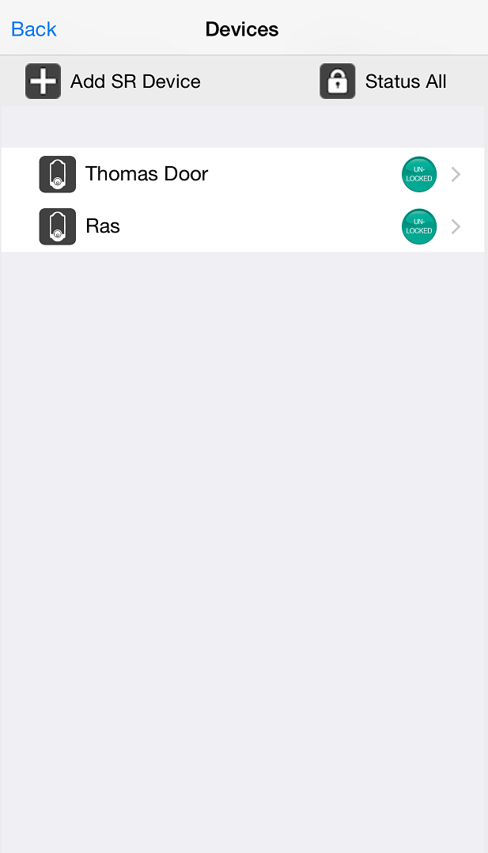

**Figure 86: Devices Screen**  **Figure 87: Devices Screen** **Figure 88: Devices Status Screen**

## 

## Switching between devices

To switch between SR KEELER, the user must go to the “Devices” menu at the bottom of the SecuRemote® App home screen. All managed SR Devices will be displayed, and the user can select the SR Devices they want to operate.

**Example:** The user is added with two SR device “Thomas Door” (Keeler) and “RAS” device. To operate “Thomas Door,” the user selects that name from the listed devices. The selected SR KEELER’s Home screen will appear on the home screen of the SR Smart® app.

1. Click on “Devices” from Home screen. Refer Figure 89.
2. Select Device from “Devices” screen. Refer Figure 90.
3. It will display selected device in “Home” screen and confirmation message will display. Refer Figure 91.

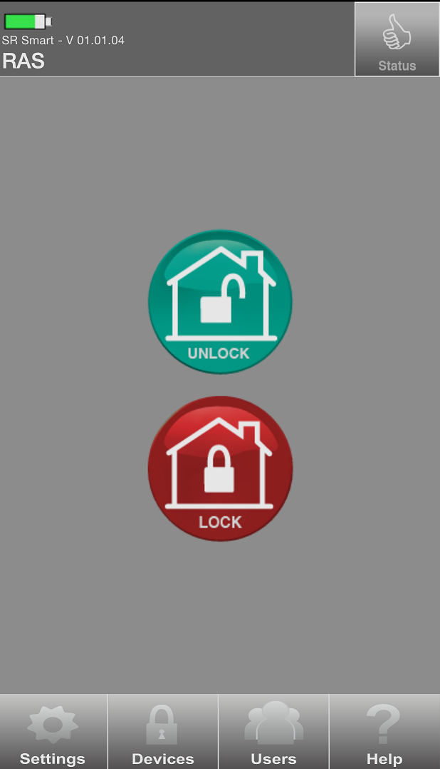 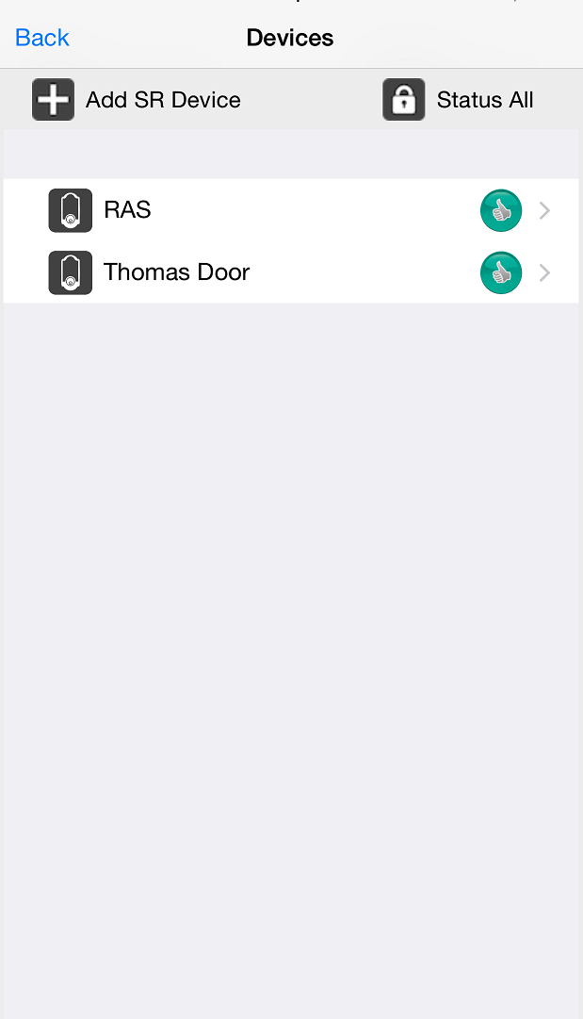 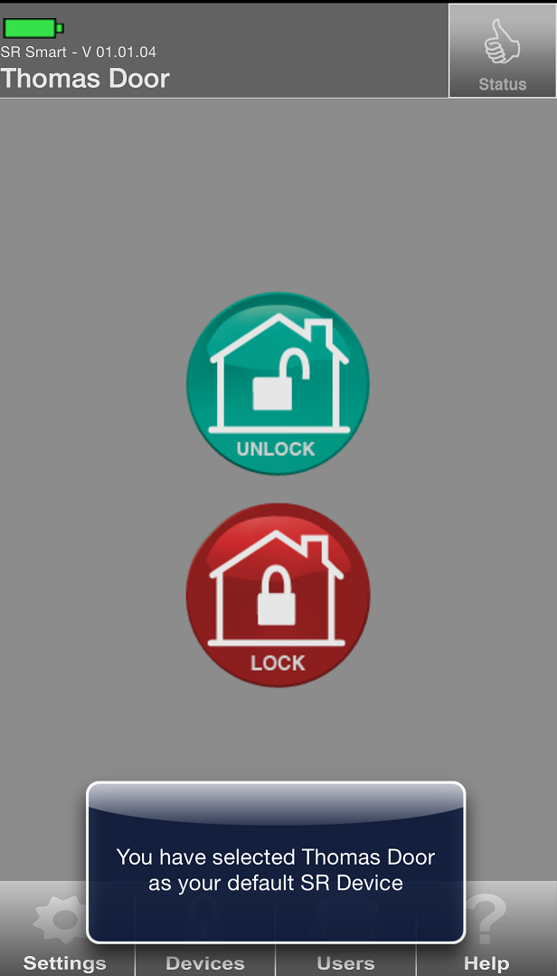

Figure 89: Home Screen Figure 90: Devices Screen Figure 91: Change Home Screen

# Users Management

User List provides the following functionality for each selected user:

* Add/Delete users
* Send SMS and Email to a User

This option allows the admin to invite, delete user. Access to this option is protected through the Admin Credential.

**Once invited, the Admin can share the Invite Code with the new user through: Email or SMS**

|  |  |
| --- | --- |
| Email | This option will sent email with new invite code using email address provided for the new user. The new user then enters this Code and serial number of the SR KEELER when this new user installs and launches the SR Smart BLE Application and tries to pair with the SR KEELER device. |
| SMS | This option will sent SMS with new invite code using phone number provided for the new user. The new user then enters this Code and serial number of the SR KEELER when this new user installs and launches the SR Smart BLE Application and tries to pair with the SR KEELER device. |

## 

## Add User

## Add User from Contact Book

The Admin can invite other users by clicking > ‘Invite User’ on the Users screen. Choose the invitee from the Contacts list, or enter the invitee’s name, email address, and mobile number. Next, choose the access type. Finally, click “Get Invite Code” to generate the invitee’s access code.

1. Click on “Users” from Home Screen. Refer Figure 92.
2. It will display “Access Devices” Screen with “Invite User” and “Add Keyfob” options. Click on “Invite User”. Refer Figure 93.
3. It will display “Administrator Details” Screen for user validation. Refer Figure 94.

 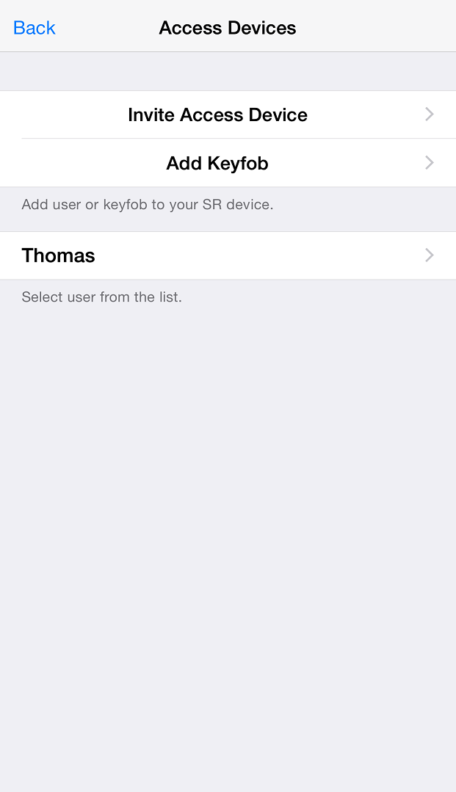 

Figure 92: Home Screen Figure 93: Access Devices  Figure 94: Admin Validation

1. Enter Administrator “EMAIL ID” and “PASSWORD” and click on “Validate Details”. It will display “Validating Administrator” activity message. Refer Figure 95.
2. It will display “Invite Users” screen with an option to select from Contacts and Field to enter user name. It also displays options to send User alert via email or SMS for the selected user. Click on “Select from contacts”. Refer Figure 96. You can directly enter name as per your choice as well.
3. Phone Contact list will appear. Select any contact from phone book. Refer Figure 97.

 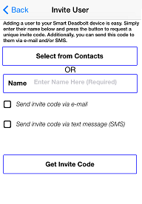 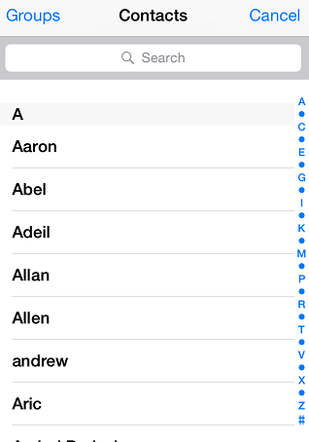

Figure 95: Admin Validate Message Figure 96: Phone contact Book Figure 97: Invite User Screen

1. It will display selected contact from the contact list. Click on contact number. Refer Figure 98.
2. It will display “Invite User” screen with option to send User alert via email or SMS.

Refer Figure 99.

1. Click on Check boxes and fill mandatory information then click on “Get Invite Code”. Refer Figure 100.

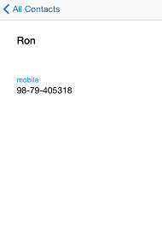 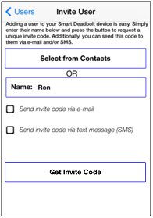 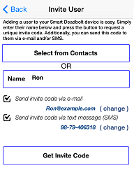

Figure 98: User Detail Figure 99: Invite User Screen Figure 100: Invite User Screen

1. It will display “Inviting User” activity message. Refer Figure 101.
2. Invite code is generated with a display message to “Notify User” through the chosen mode with “YES” and “NO” option. Select desired option. Refer Figure 102.
3. It will display added user name in “Access Devices” screen. Refer Figure 103.

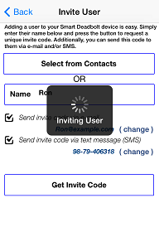 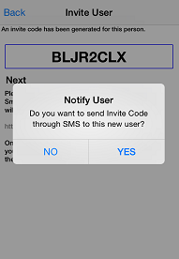 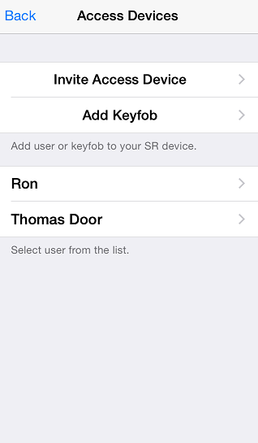

Figure 101: Inviting User Message Figure 102: Notify User  Figure 103: Changed picture

***Note:*** To add a user, using phone’s contact list, click on ‘Select from Contacts’. The new user’s details will automatically appear, and the Admin can just click on ‘Get Invite Code’ to add that user to the users list.

## About Access Device

User can view list of all user and detail in “About Access Device” screen.

1. From “Access Device” screen click on “Ron“. Refer Figure 104.
2. It will display “Access Device” screen, Click on “About Access Device” option. Refer Figure 105.
3. It will display “About Device” with user’s Smartphone details Refer Figure 106.

 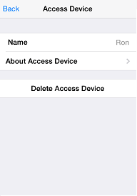 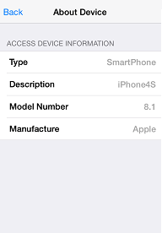

Figure 104: Access Device Screen Figure 105: Access Device Screen Figure 106: About Device Screen

## Delete Access Device

1. From “Access Device Screen” screen click on “User name (RON) “. Refer Figure 107.
2. It will display “Access Device” screen with all the user options, click on “Delete Access Device”. Refer Figure 108.
3. It will display “Removing User” message with “Yes” and “No” button and Click on “Yes”. Click on “Yes”. Refer Figure 109.

  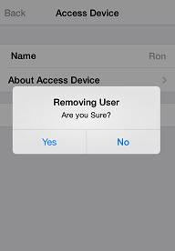

Figure 107: Access Device Screen Figure 108: Admin Screen  Figure 109: Removing User

1. It will display “Removing User” activity message. Refer Figure 110.
2. It will display “Access Device “screen with list of current access devices. Refer Figure 111.

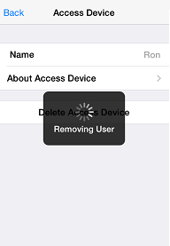 

Figure 110: Removing User Message Figure 111: Access Device Screen

***Note:*** Admin User cannot delete itself.

## Keyfob

It allows the addition of a Keyfob as another user so it can operate the SR KEELER, a SR KEELER package may include one or more Keyfob. One Keyfob device can operate up to 4 Locks (SR KEELER).

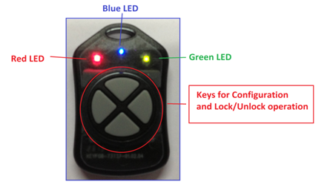

The Keyfob must be configured before it can be added as a user. To configure a Keyfob, the Smart phone and the Keyfob must be within radius of 20 feet from the Lock.

## Add Keyfob

1. Click on “Users” from Home Screen. Refer Figure 112.
2. It will display “Access Devices” Screen with “Invite User” and “Add Keyfob” options. Click on “Invite User”. Refer Figure 113.
3. It will display “Administrator Details” Screen for user validation. Refer Figure 114.

  

Figure 112: Home Screen Figure 113: Access Devices  Figure 114: Admin Validation

1. It will display “Access Devices” Screen with “Invite User” and “Add Keyfob” options. Click on “Invite Access Device”. Refer Figure 115.
2. It will display “Administrator Details” Screen for user validation. Refer Figure 116.

 

Figure 115: Users Screen Figure 116: Admin Validation Screen

1. Enter Administrator “EMAIL ID” and “PASSWORD” and click on “Validate Details”. It will display “Validating Administrator” activity message. Refer Figure 117.
2. It will prompt “Add Keyfob message” with “OK” button, click on “OK” button. Refer Figure 118.
3. It will display “searching for Keyfob” message along with “Red” and “Green” LED indication, Press and hold any Keyfob button for 5 seconds to configure Keyfob. Refer Figure 119.

 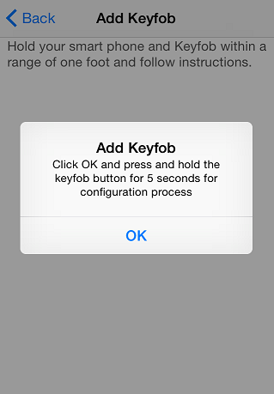 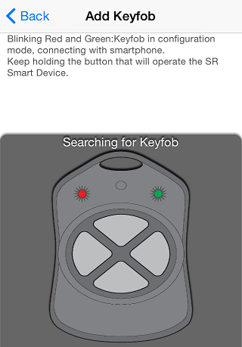

Figure 117: Admin Validate Message  Figure 118: Add Keyfob Figure 119: Searching Keyfob

1. When Keyfob is detected the SR KEELER it will display a message “Configuring Keyfob, please wait” with “Blue LED” indication. Refer Figure 120.
2. Once configured, it will display “Keyfob button is configured” toast message. Refer Figure 121.
3. It will display a message “Keyfob activated to work with this SR KEELER by pressing the button: Connecting - Blue LED, Unlocking – GREEN LED for 3 sec, Locking - RED LED for 3 seconds” with “OK” button. Refer Figure 122.

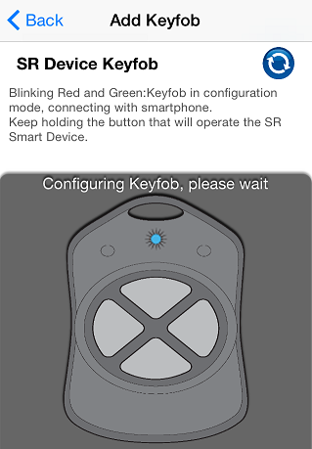 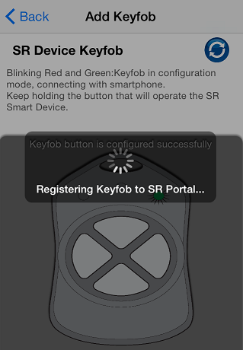 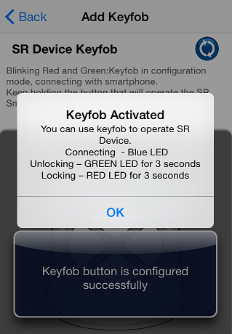

Figure 120: Keyfob Configuring Figure 121: Keyfob configured Figure 122: Keyfob button activated

## About Keyfob Device

1. From “Access Devices” screen click on “KEYFOB-96235634“. Refer Figure 123.
2. It will display “Access Device” screen, Click on “About Access Device” option. Refer Figure 124.
3. It will display “About Device” with Key fob’s details. Refer Figure 125.

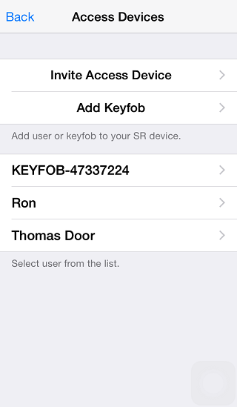 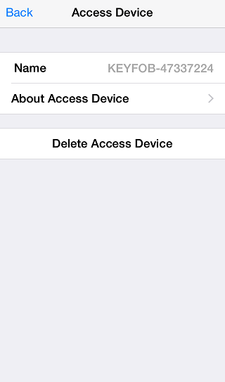 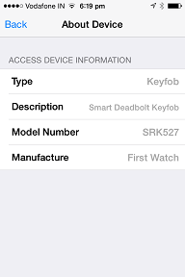

Figure 123: Access Devices Screen Figure 124: Access Device screen Figure 125: About Device Screen

## Delete Keyfob Device

1. From “Access Devices” screen click on “KEYFOB”. Refer Figure 126.
2. It will display “Access Device” screen with all the user options, click on “Delete Access Device”. Refer Figure 127.
3. It will display “Removing User” message with “Yes” and “No” button and Click on “Yes”. Refer Figure 128.

  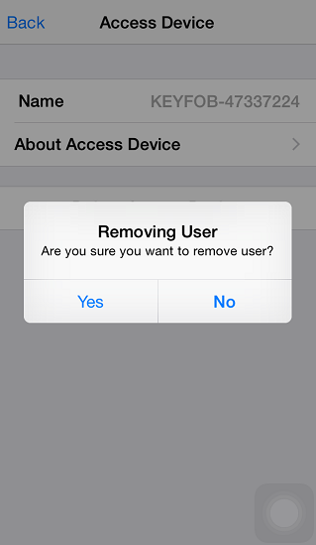

Figure 126: Access Device Screen Figure 127: Access Device screen  Figure 128: Removing User screen

1. It will display “Removing User” activity message. Refer Figure 129.
2. After that it will redirect to the “Access Devices” screen with current access device list. Refer Figure 130.

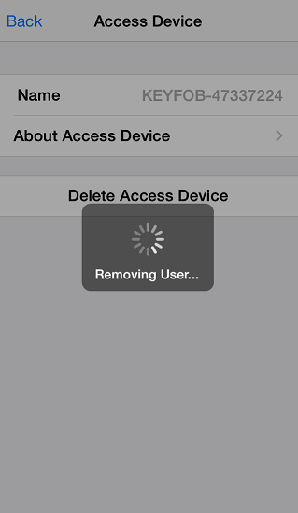 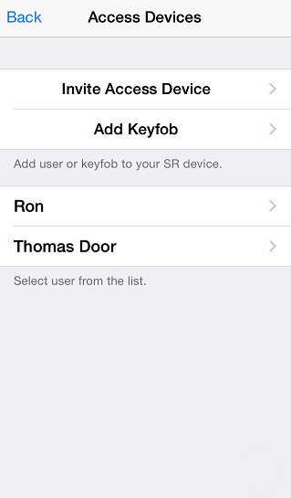

Figure 129: Removing User Message   Figure 130: Access Devices Screen

# Help Option

In this option user can view “HELP” file, Online FAQ, Release Notes, Build Version of the app an from developer option user can enable “Camera”. User can also submit an issue using Submit an Issue feature. Clear Device log will create all logs generated on your mobile device.

* Help
* Developer Options

## Help

When user clicks on “Help” option it shows help file to the user.

1. Click on “Help” option from home screen. Refer Figure 131.
2. Click on “Help” from “Information” screen. Refer Figure 132.
3. It shows “Help” file. Refer Figure 133.

 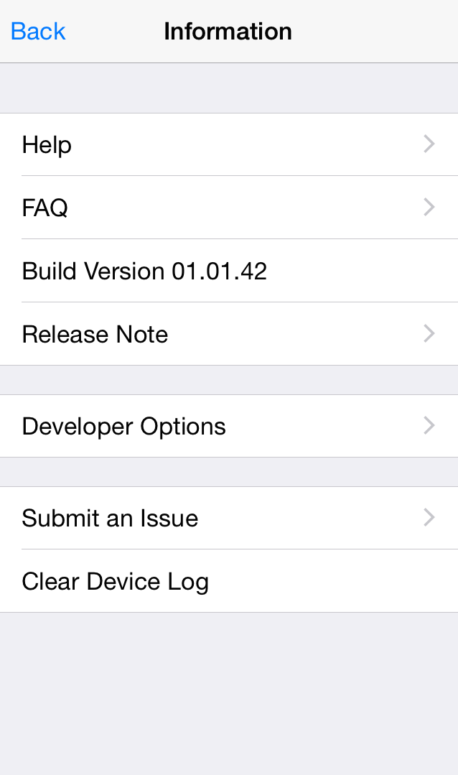 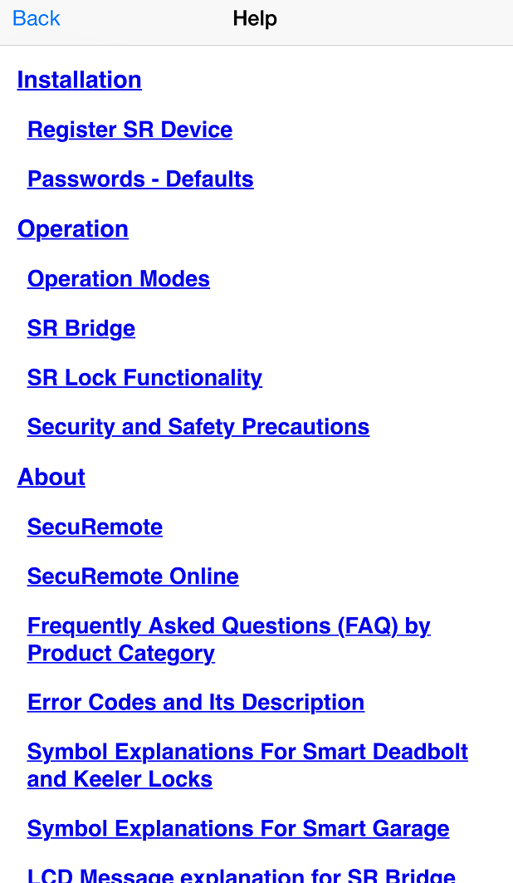

**Figure 131: Home Screen** **Figure 132: Information Screen**  **Figure 133: Help Screen**

## Developer Options

## Camera Settings

**IP Camera support**

**Camera Type**

1. **D-Link: Following camera models are supported:**

* DCS-942L
* DCS-930L
* DCS-933L

1. **Foscam: Following camera models are supported:**

* FI8910W
* FI8918W

**Set up IP camera**

**Following Information will be required to Set Camera IP**

* Camera Type.
* Select camera model
* Enter external (WAN) IP address (Host)
* Enter port number
* Enter User name
* Enter Password

**External (WAN) IP address**

From PC or Phone, which is connected to same router to which IP camera is connected, open browser and type.

**Steps to Enable IP camera**

1. Click on “Help” option to open “Help” screen. Refer Figure 134.
2. Click on “Developer Options” and it will prompt for “Developer PIN”. Refer Figure 135.
3. Enter default PIN “123456” as Developer PIN. Refer Figure 136.

  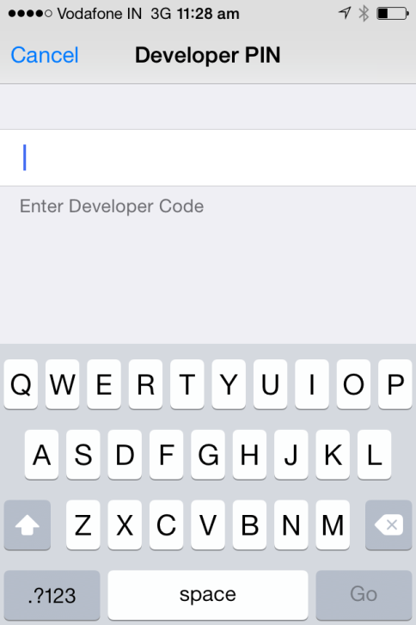

Figure 134: SR app Home Screen  Figure 135: Help Screen Figure 136: Developer PIN Input Screen

1. It will display “Developer Options” screen, click on “Camera Settings”. Refer Figure 137.
2. Enable “Camera”, fill all mandatory information, “Save” the settings & return to the Home Screen.

Refer Figure 138.

1. Camera picture will display in “SR App Home Screen”. Refer Figure 139.

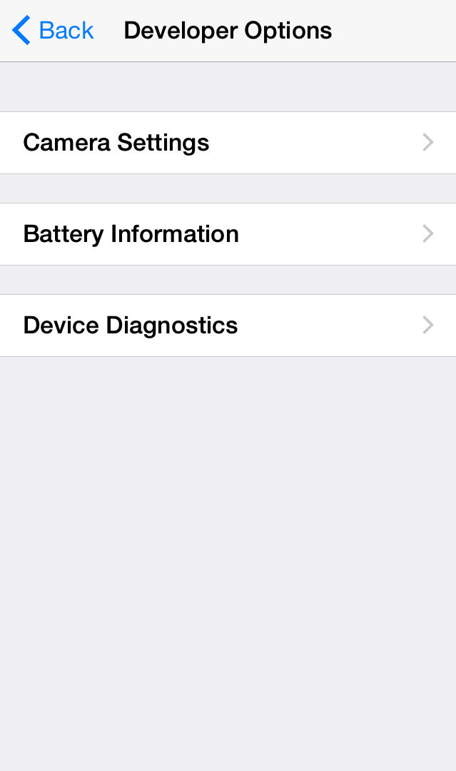 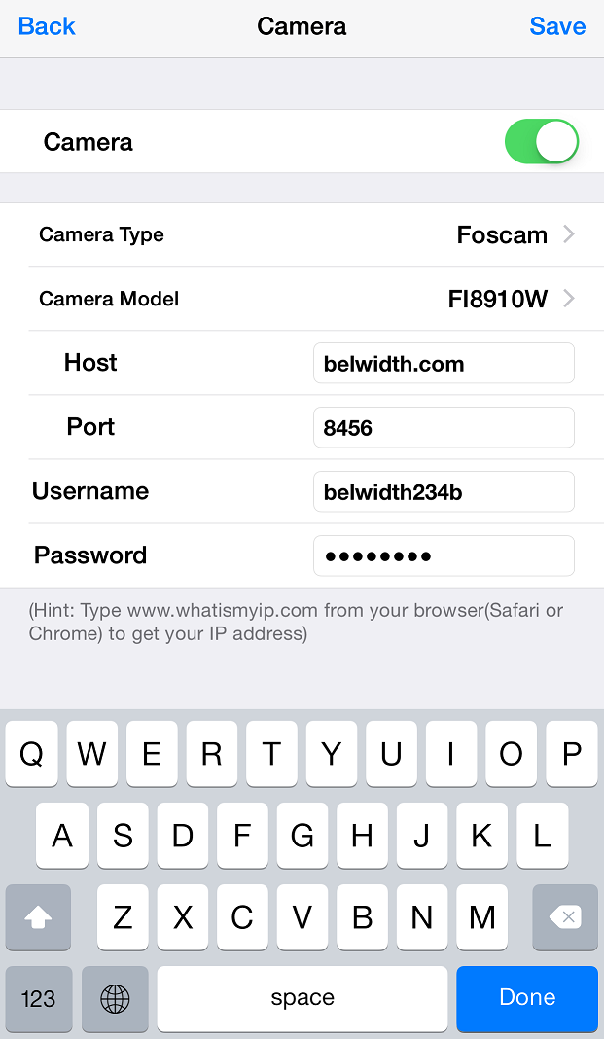 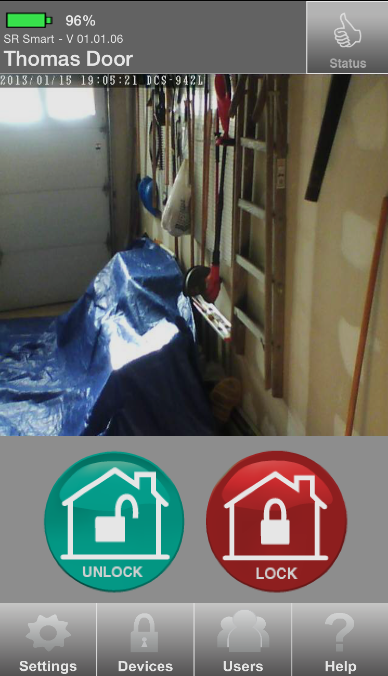

Figure 137: Developer Options Screen Figure 138: Camera User Input  Figure 139: SR App Home Screen

## Battery Information

This option allows user to check detail usage of battery, which includes following options.

* Type of Power supply (Alkaline, Lithium and Mains)
* Total Hours
* Remaining Hours
* Operation Done

1. Click on “Battery Information” option from “Developer Option” screen. Refer Figure 140.
2. “Updating Battery Information” activity screen will display. Refer Figure 141.
3. Detail battery information will display in “Battery Information” screen. Refer Figure 142.

 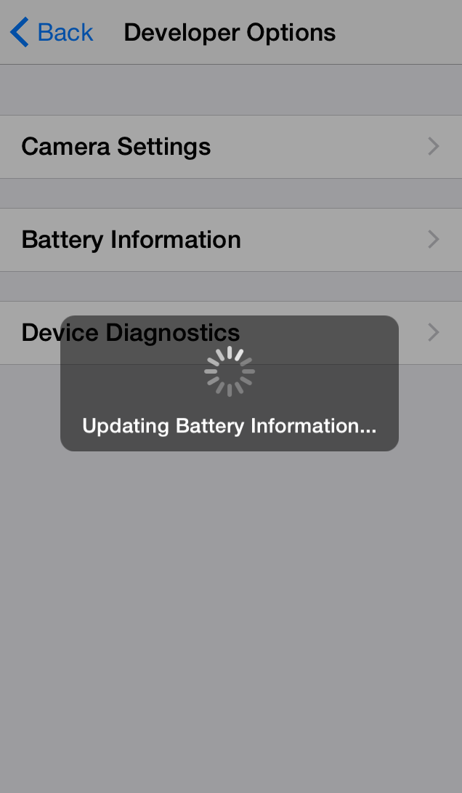 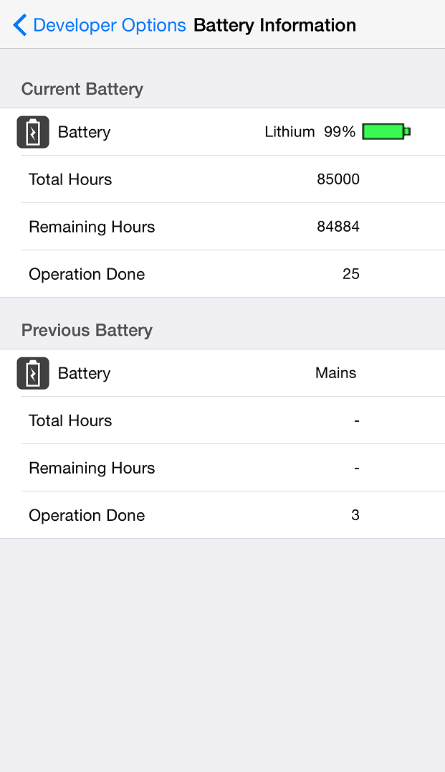

Figure 140: Developer Options Screen Figure 141: Updating Screen Figure 142: Battery Information

## Device Diagnostics

This option allows user to check diagnostics detail and other problem in SR Device, which includes following options.

* SR Network Details
* User Details
* Error Details

1. Click on “Device Diagnostics” option from “Developer Option” screen. Refer Figure 140.

2. “Updating Device Diagnostics Information” activity screen will display. Refer Figure 141.

1. Detail Device Diagnostics information will display in “Battery Information” screen. Refer Figure 142.

 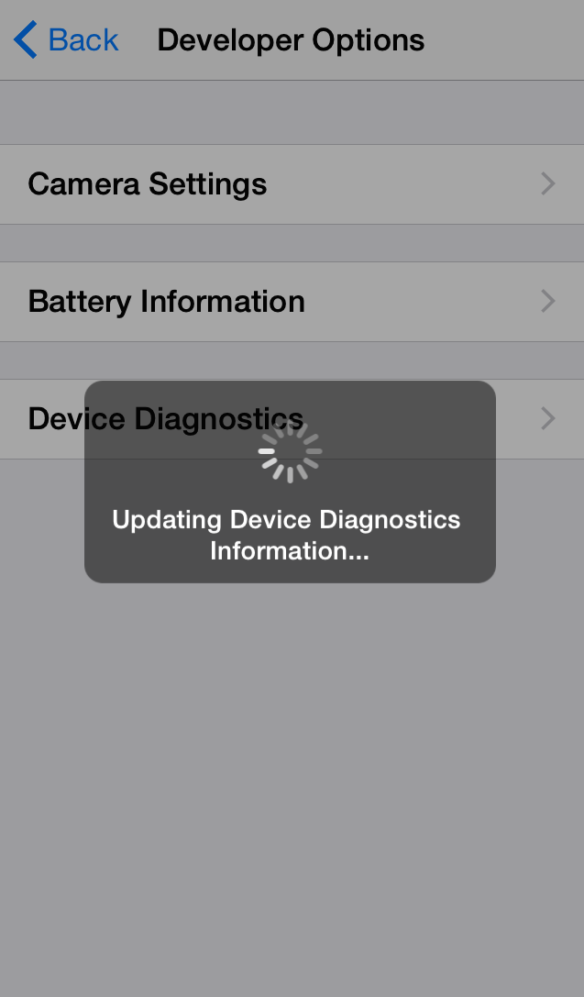 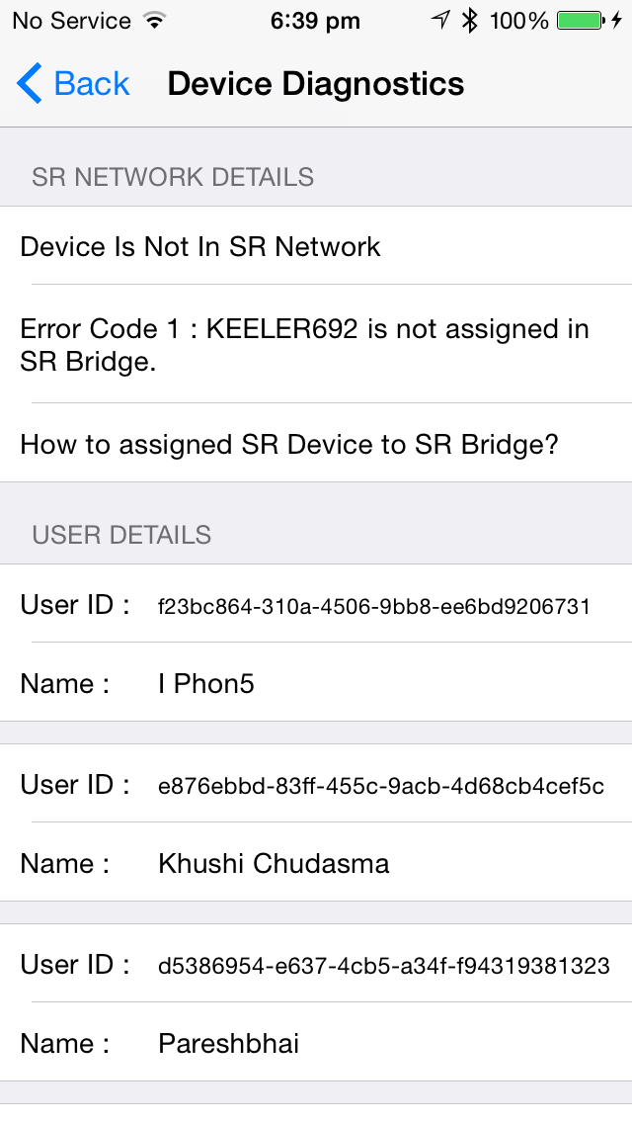

Figure 118: Developer Options Screen Figure 119: Updating Screen Figure 120: Battery Information

# SR Portal

SecuRemote® Online allows users to expand the capabilities of SecuRemote Smart™. This web-based user management and authorization system lets the SecuRemote Smart™ Administrator use a computer to remotely manage users and their access times/days, and to monitor door use. SecuRemote® Online brings more convenience, control and security to families.

## Sign-In Page

The e-mail address and password you used during registration are required to log-in to SecuRemote® Online. Your account must have been previously activated via the confirmation link sent to your e-mail.

You can choose to have your password reset by following the “Forgot your Password?” This requires you to know the e-mail address and last name used to register the account. An e-mail Message is then sent to you with a link that can be used to complete the password reset. Refer Figure 169 Figure 170.

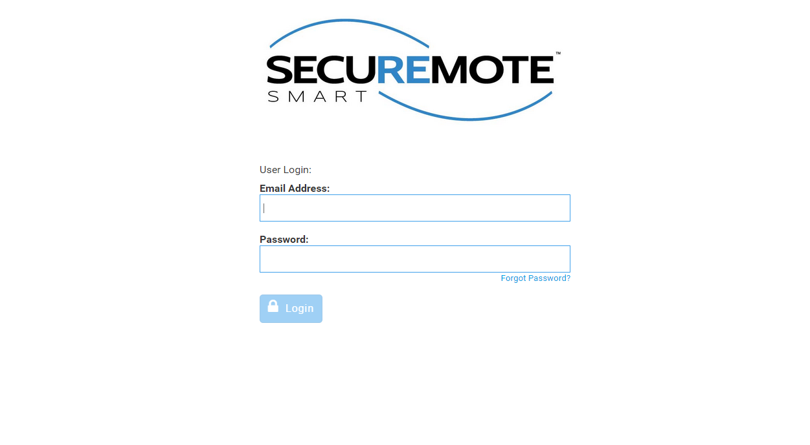

Figure 169: Sign In

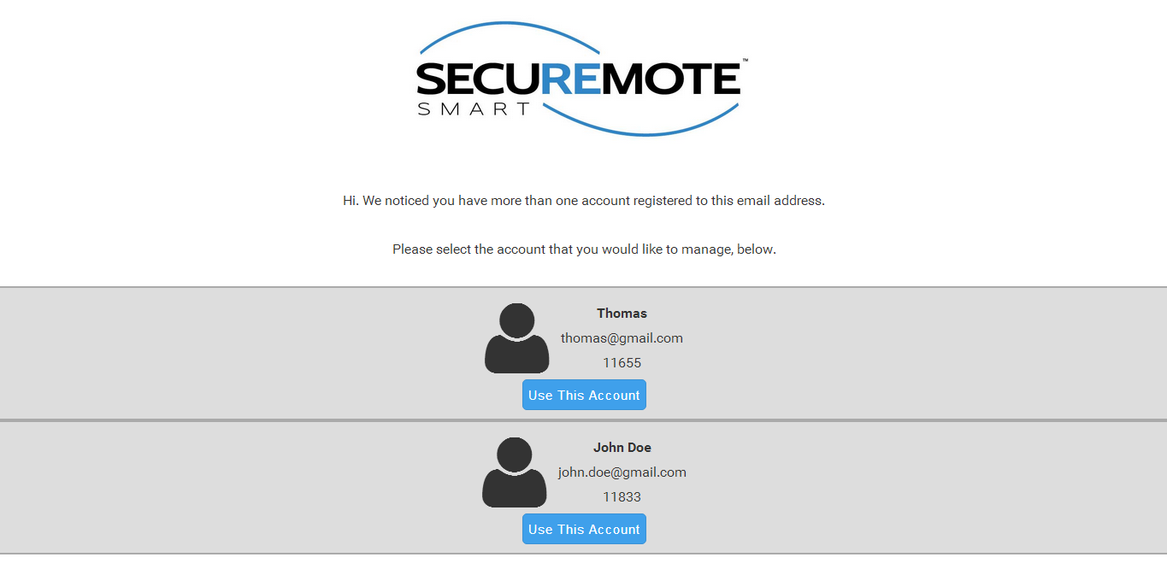

Figure 170: Sign In

## Secure Home Page

Dashboard page will display with recent activities and welcome message. Refer Figure 171.

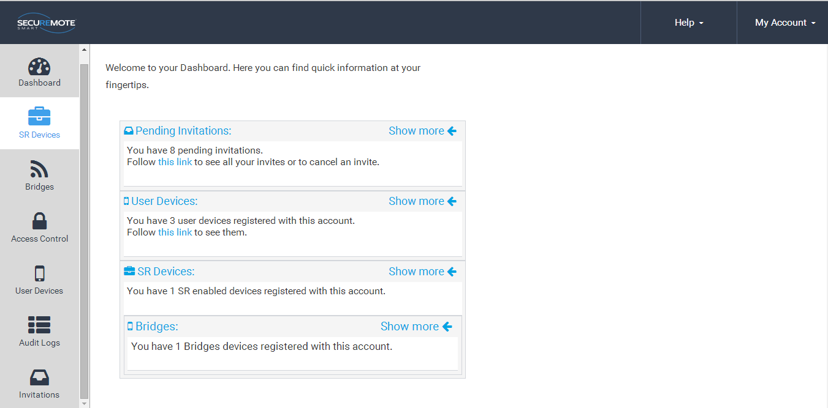

Figure 171: SecuRemote® Smart Home Page

## Add SR device

First user has to register the device from SecuRemote Smart™ Online site.

1. Select “SR Device” option and click on “Add SR Device”. Refer Figure 172.

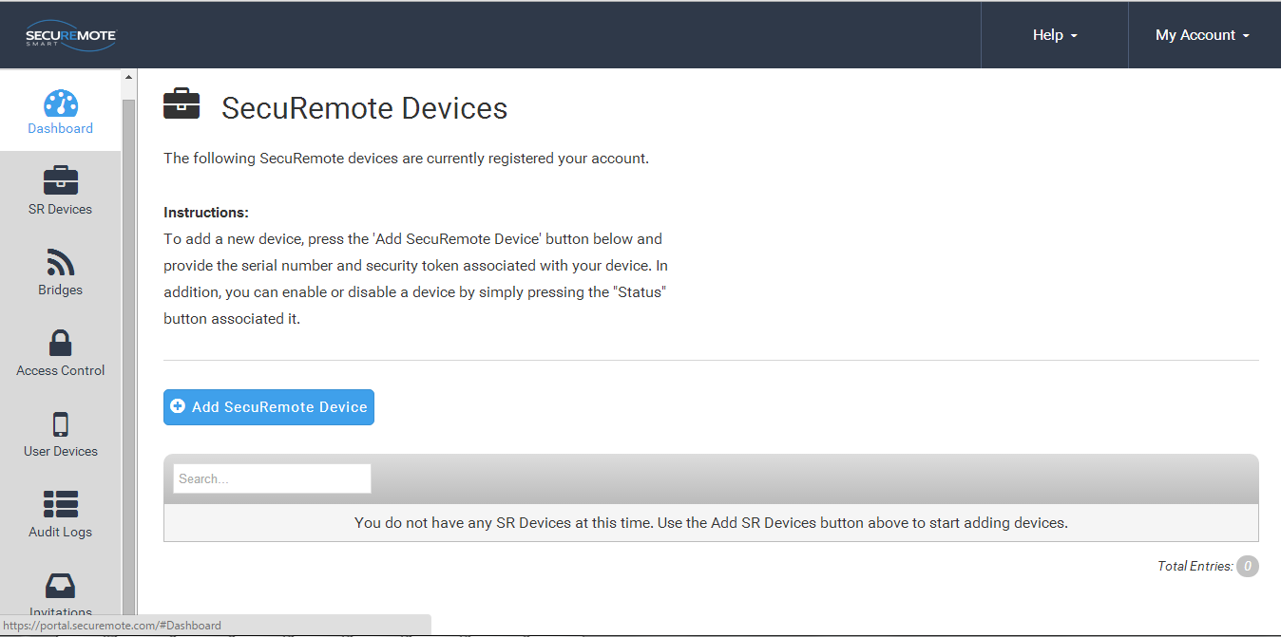

Figure 172: All devices

1. Requires entry of Serial number, Security token and Name of the SR KEELER and click on “Add SR Device”. Refer Figure 173.

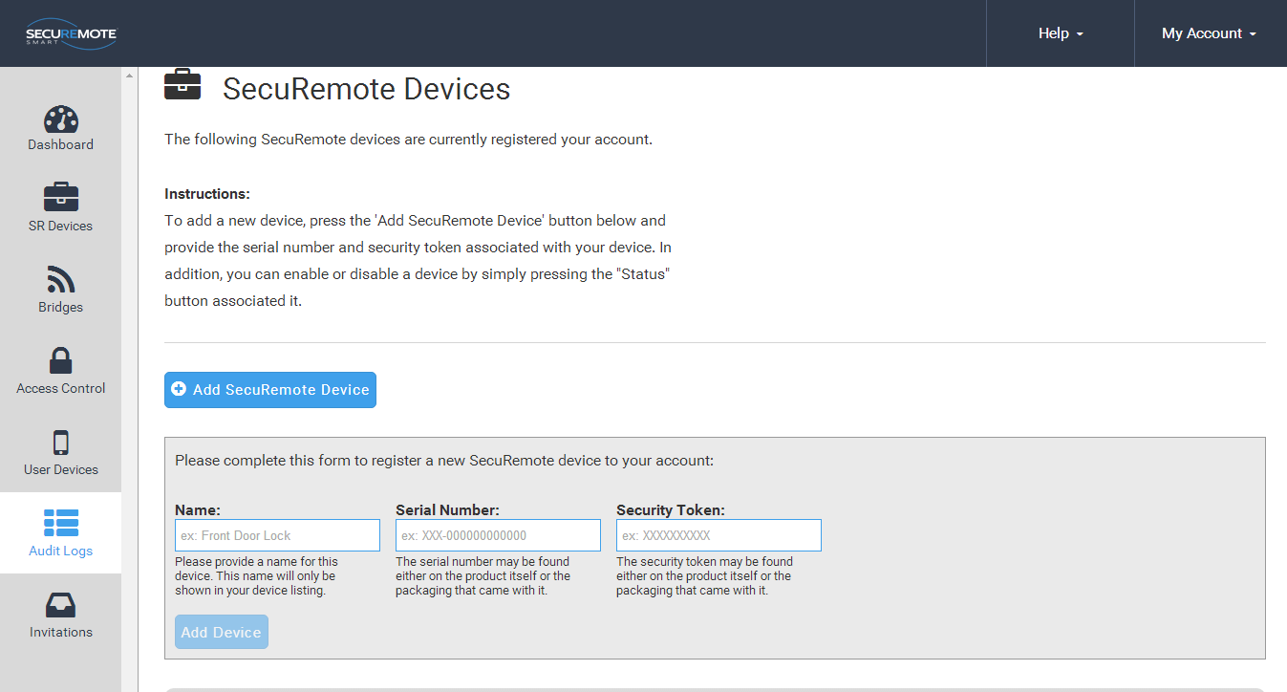

Figure 173: New device Registration

## All SR Devices

All devices belonging to the account are show in “SR Devices” screen. Refer Figure 174.

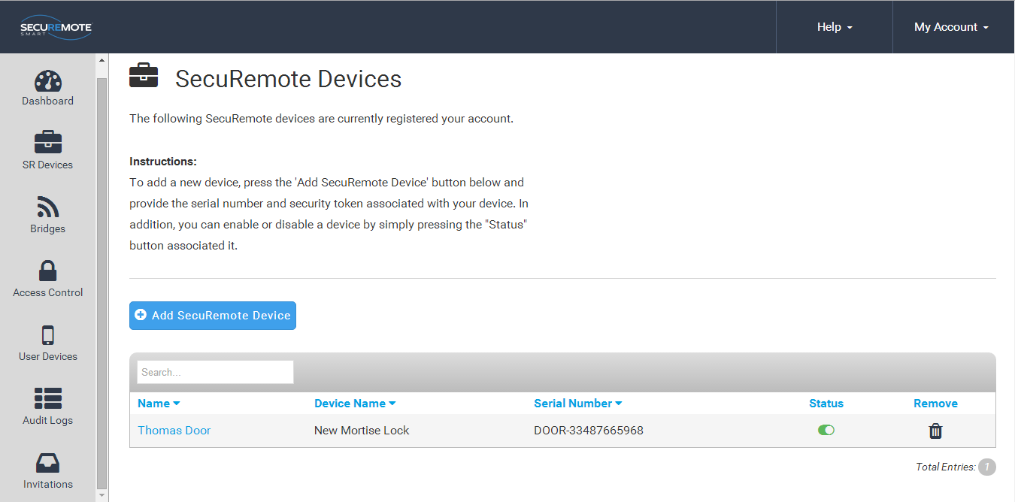

Figure 174: All devices

## 

## **Invite a New User Device**

Enter user name in the “Name” field and Click on “Request Invite Code”. You cannot enter a user with a name that already exist. Refer Figure 175.

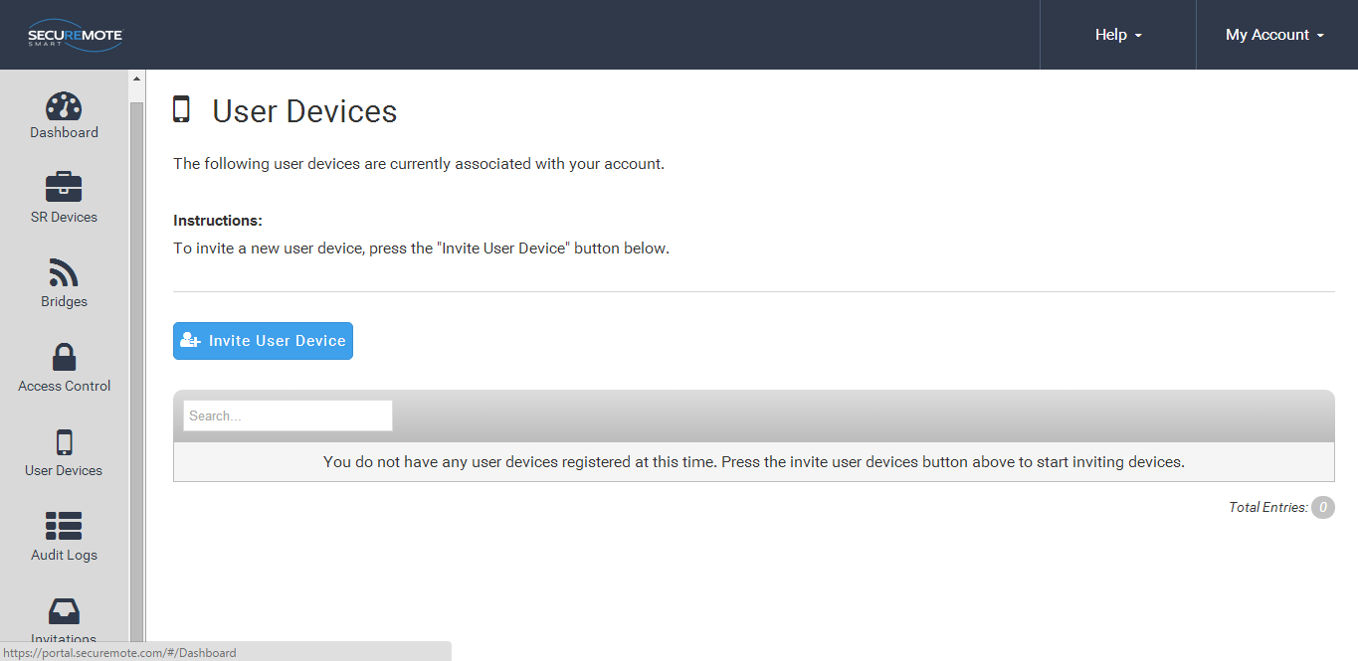

Figure 175: Invite a New User

New screen will show generated invited code and confirmation message will appear right hand bottom corner. Refer Figure 176.

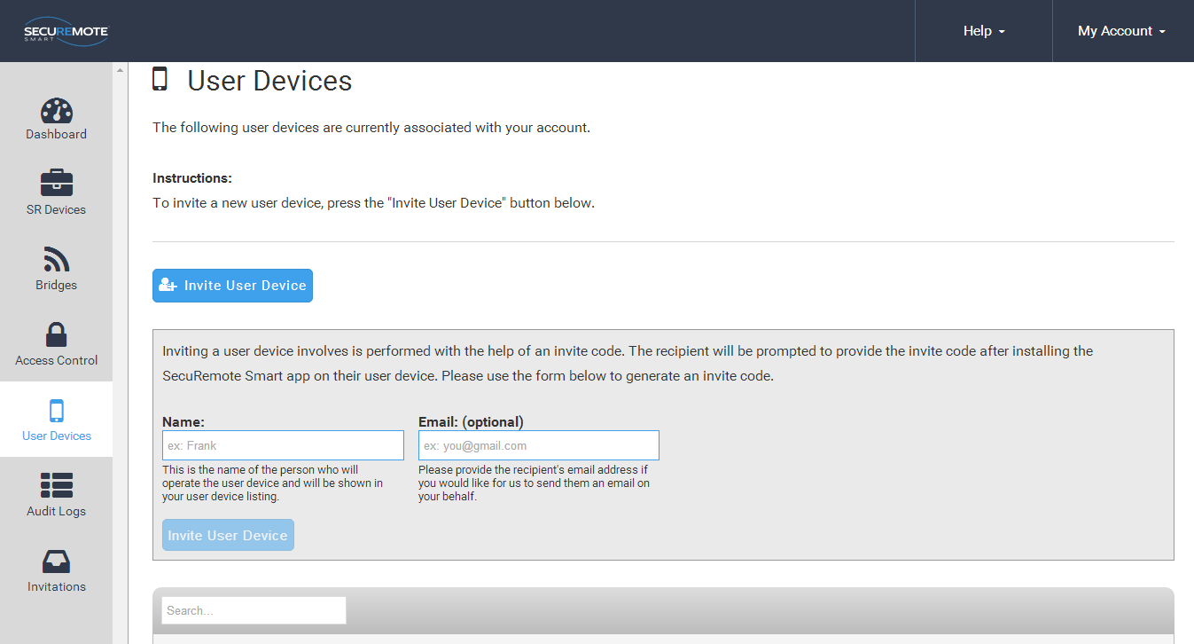

Figure 176: User Invitation

## **All Users**

1. The account administrator cannot be removed from the account.
2. Clicking on the user’s name brings up the “Edit user” dialog.
3. Security Link is an advanced security feature that allows the SecuRemote® Online service to uniquely identify a user’s smartphone. When a SecuRemote Smart™ app is run for the first time it generates a unique security token, a large random number that it sends to SecuRemote® Online every time an authorization request is made. This token must match the one used on previous requests in order for the request to be authorized. This ensures that no other smartphone can be used to initiate an authorization request on behalf of that user. Refer Figure 177.

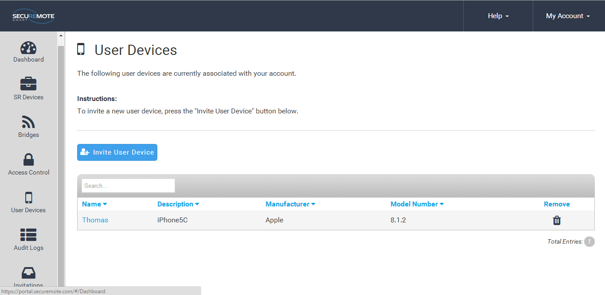

Figure 177: All Users

## **Audit Logs**

* 1. Audit log entries are shown in UTC by default on all accounts since it’s possible that they have multiple devices in different time zones.
  2. Audit logs are maintained for 365 days, the maximum length, by default for each account. The user can reduce this to as little as 7.
  3. Downloading the logs in Excel, CSV or XML format will download the entire audit log history. It is not affected by the filters used on the table above. Refer Figure 178.

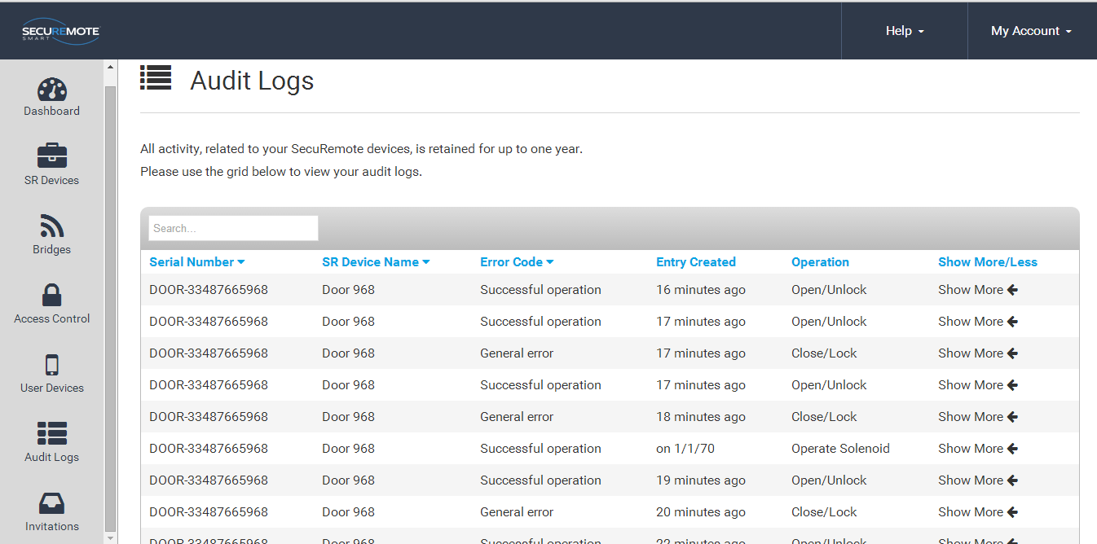

**Figure 178: Audit Logs**

## Register SR Bridge

Enter valid Serial number and click on Register SR Bridge.

Before registering the bridge user has to make sure bridge is powered on. It has to be connected with router through RJ 45 LAN cable in case Ethernet Bridge.

Refer Figure 179 Refer Figure 180.

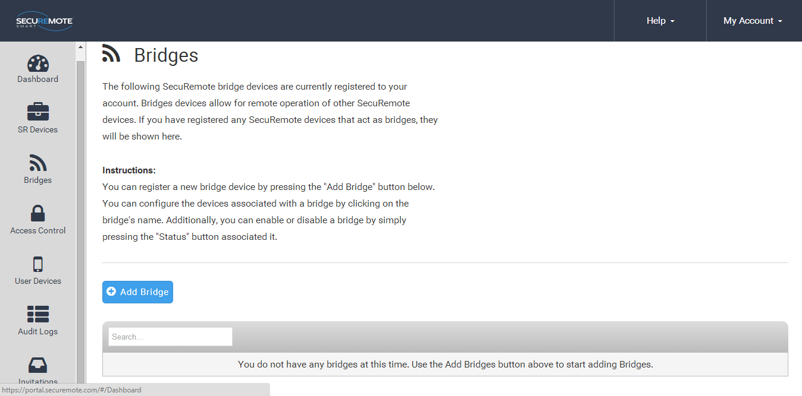

**Figure 179: New SR Bridge Registration**

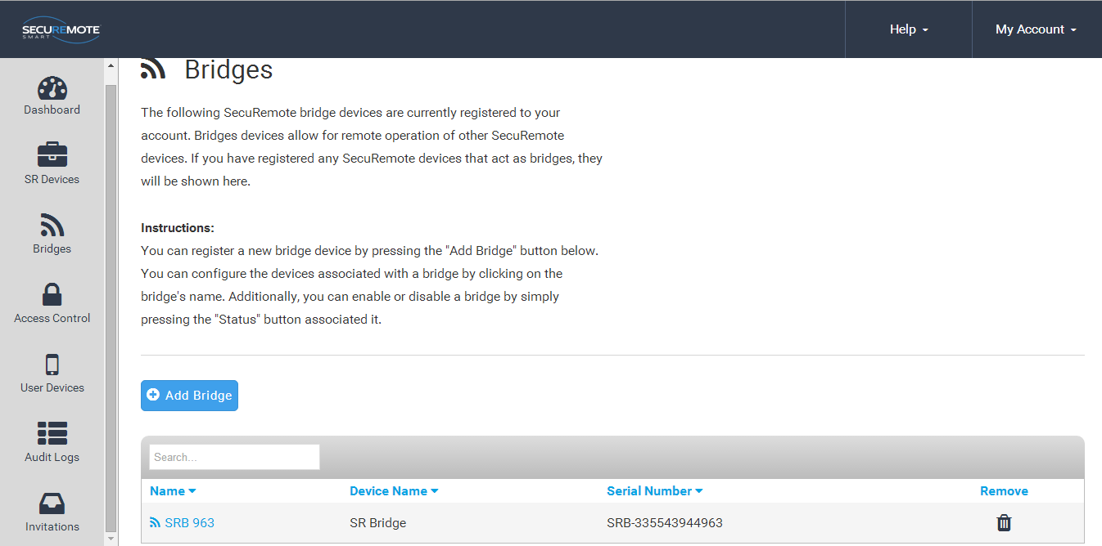

**Figure 180: New SR Bridge Registration**

## **Configure SR Bridge**

Click on SR Bridge Name to assign SR Bridge to SR Keeler. Refer Figure 181.

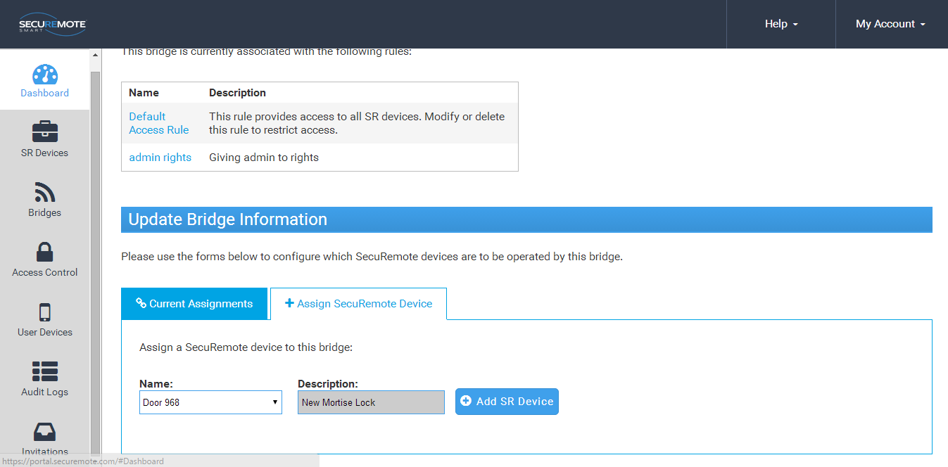

**Figure 181: Manage SR KEELER**

Please click on “Add SR Device” button which you want to Configure and confirm. Refer Figure 182.

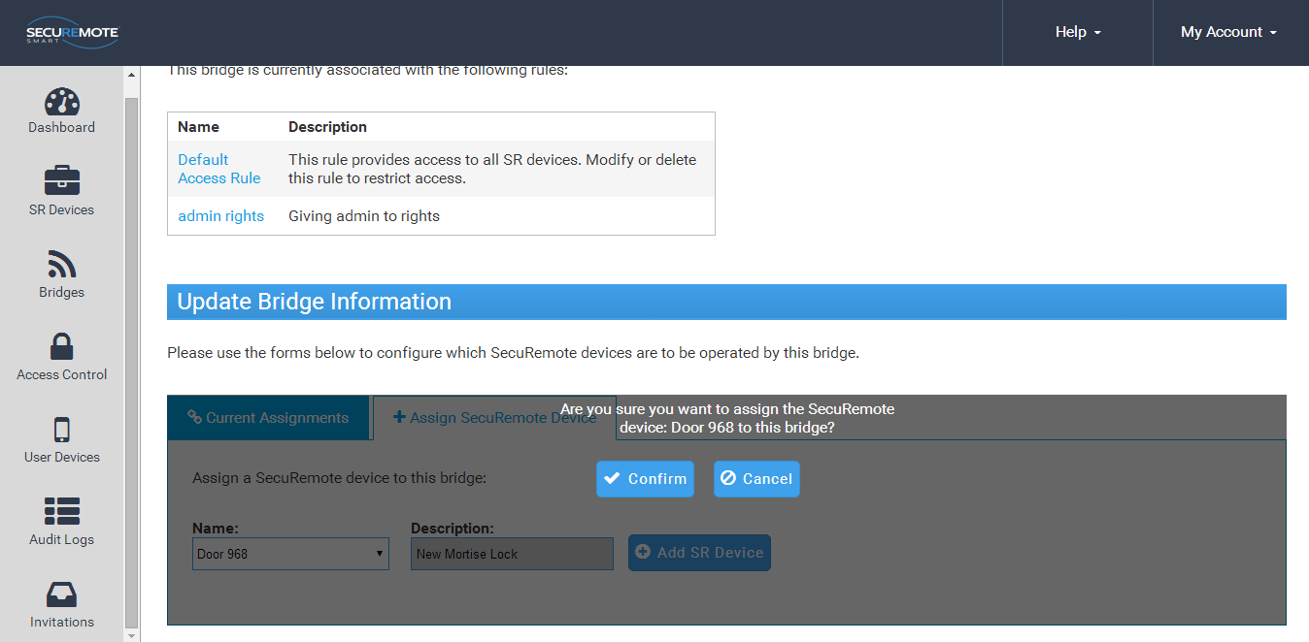

**Figure 182: Manage SR KEELER**

Selected device’s name will show in Current Assignments list. Refer Figure 183.

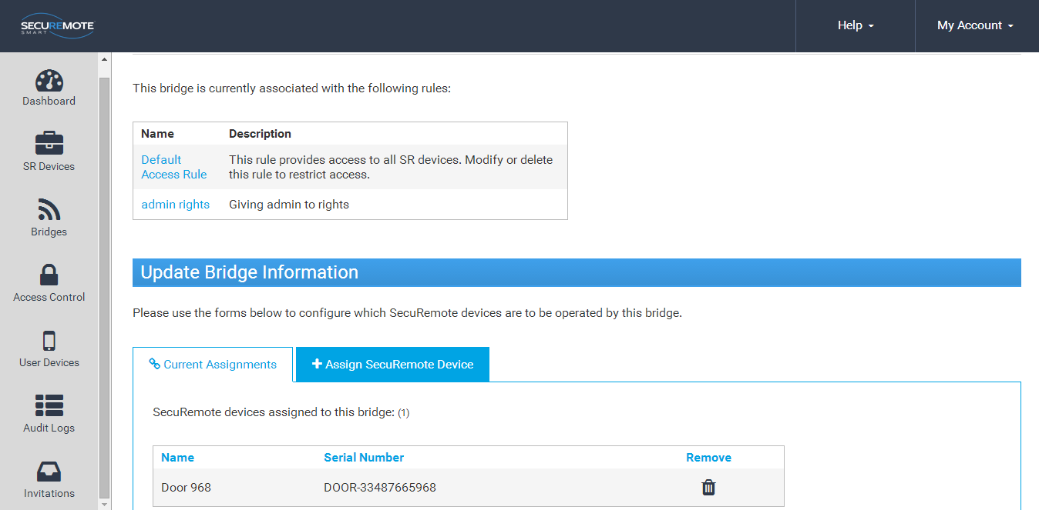

**Figure 183: Manage SR KEELER**

## **Dashboard Option**

This screen shows recent activities. Refer Figure 184.

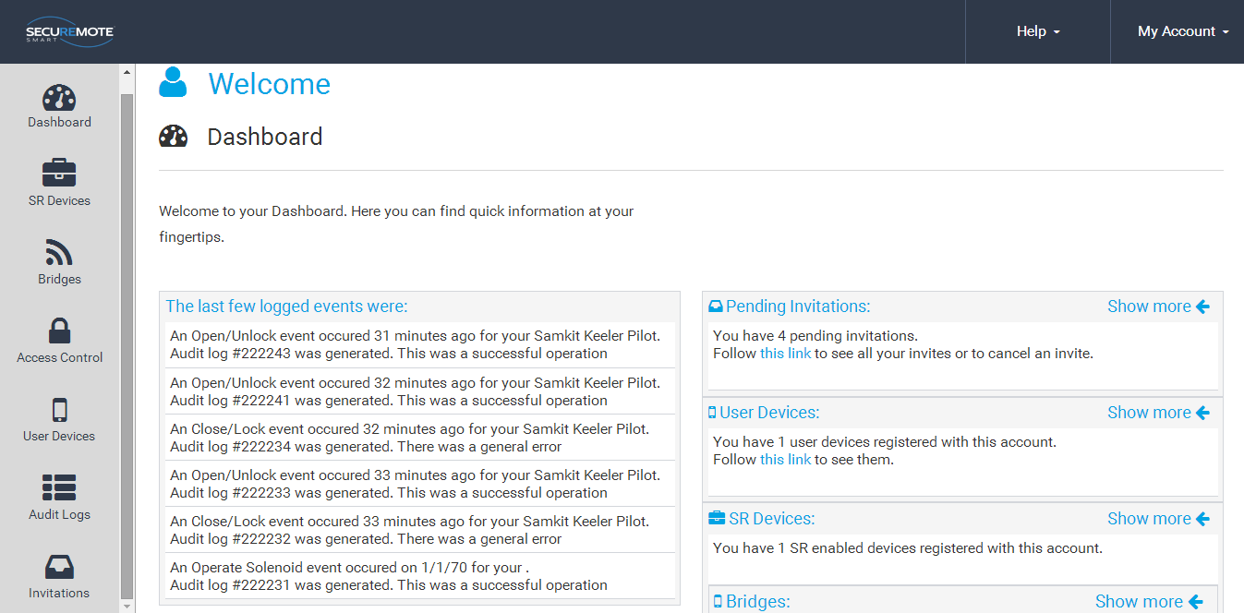

**Figure 184: Dashboard**

## **Invites Option**

This screen shows invitation send by users. Refer Figure 185.

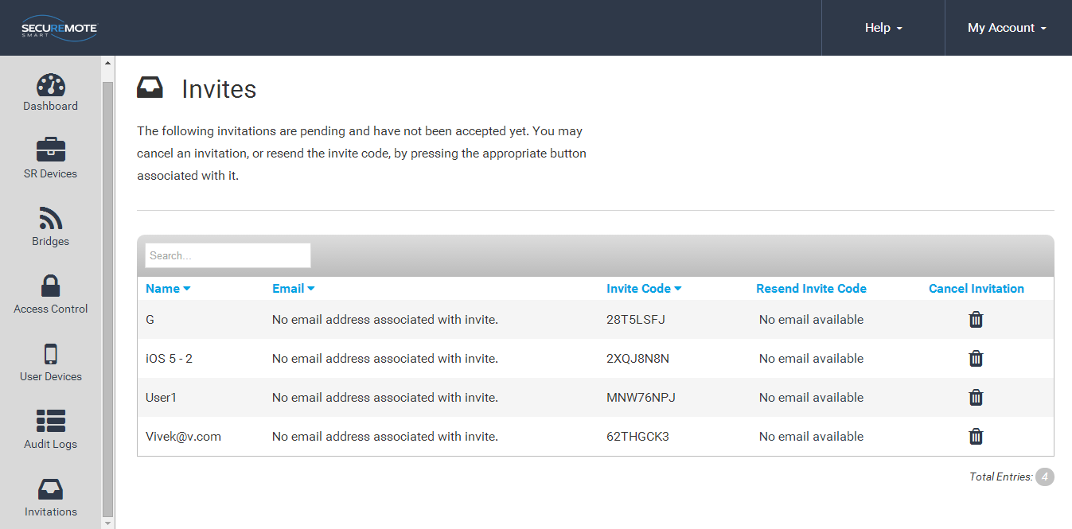

Figure 185: Invite Screen

# Remote Mode

This mode provide user to operate the device from remote location via internet connectivity.

User also has all the online mode features.

SR KEELER comes with built in SR Bridge CDMA module. For SR KEELER module user need to connect to power supply through adapter and it will automatically connect with register network. It will automatically enable remote operation once SR KEELER gets internet connectivity.



## **Lock operation**

1. Click on “Lock” button from Home Screen. Refer Figure 186.
2. “Safety Warning Reminder” message appears with “YES/NO” option. Click on “YES” option. Refer Figure 187.
3. Request sent to SR Portal “Toast Message” will appear. Refer Figure 188.

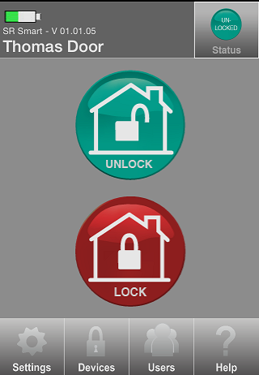 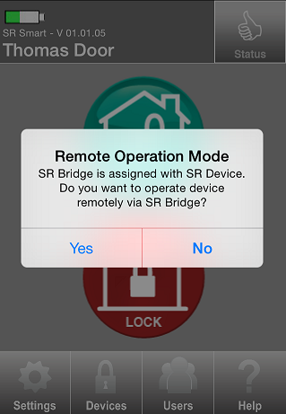 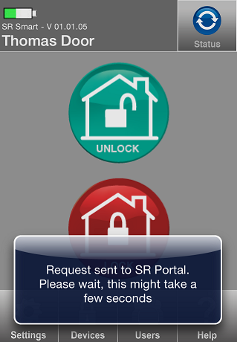

Figure 186: SR App Home Screen Figure 187: Safety Warning Message Figure 188: Request sent to SRO

1. “Lock” operation successfully performed message will appear. Refer Figure 189.
2. “Locked” status symbol will appear after the SR KEELER is “Locked” successfully. Refer Figure 190

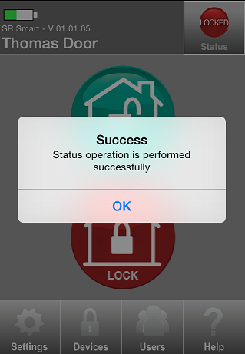 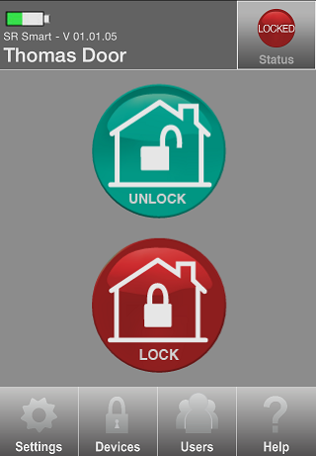

Figure 189: success Message  Figure 190: Home Screen

## **Unlock operation**

1. Click on “UNLOCK” button from Home Screen. Refer Figure 191
2. “Safety Warning Reminder” message appears with “YES/NO” option. Click on “YES” option. Refer Figure 192.
3. Request sent to SRO “Toast Message” will appear. Refer Figure 193.

  

Figure 191: Home Screen Figure 192: Safety warning Message Figure 193: Toast Message

1. “Unlock” operation successfully performed message will appear. Refer Figure 194.
2. “Unlocked” status symbol will appear after the SR KEELER is “Unlocked” successfully. Refer Figure 195

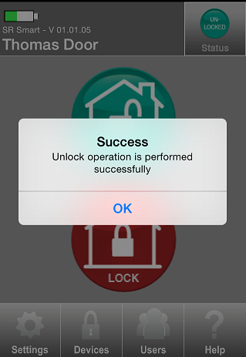 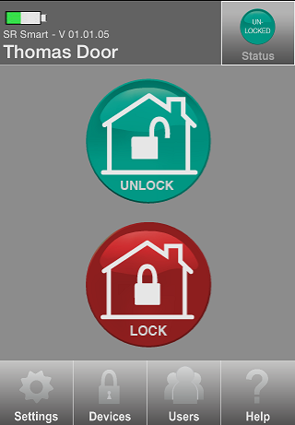

Figure 194: Success Message  Figure 195: Home Screen

## **Status operation**

1. Click on “STATUS” button from Home Screen. Refer Figure 196.
2. “Safety Warning Reminder” message appears with “YES/NO” option. Click on “YES” option. Refer Figure 197.
3. Request sent to SR Portal “Toast Message” will appear. Refer Figure 198.

**  **

Figure 196: Home Screen Figure 197: Safety warning Message Figure 198: Request sent to SRO

1. “Success” notification message will appear with “OK” option. Refer Figure 199.



Figure 199: Success Message

1. If the door is Unlocked then “Unlocked” will be indicated in Status. Refer Figure 200.
2. If the door is locked then “Locked” will be indicated in Status. Refer Figure 201.

 

Figure 200: Unlocked Status Figure 201: Locked Status

## **Remote Pairing**

Remote Pairing allows user to add SR device when it is not in Bluetooth range. User needs to enter invitation code to operate the device. The user can operate device only when device is added in SR Bridge. Remotely paired user cannot access settings of SR App.

To add user remotely follow the “Add User” steps.

# Update the SR Smart® App

## **Update the SR Smart® App for iOS devices**

Click on App Stores icon on your Home Screen. Click on “Updates” option in the bottom right corner. This will display any Apps that have updates available for your phone. To update the SR Smart App, select the SR Smart® App and click on “Update” option in the upper right corner.

## **Update the SR Smart® App for Android devices**

Update the SR Smart® App by setting your Android up for automatic updates. Click on the Android Play Store icon from your Home Screen. Click on “SR Smart®” and select “Allow Automatic Updating”.

# Remove the SR Smart**®** app from your Smartphone

**For iOS**

1. Tap and Hold on SR Smart App icon.
2. Click on Cross.
3. Message appears on screen with “Delete” and “Cancel” option.
4. Click on “Delete” option.

**For Android**

1. Go to phone “Settings”.
2. Click on “Application manager” option.
3. Select SR Smart app.
4. Click on Uninstall.
5. Message appears on screen with “Cancel” and “Uninstall” option.
6. Click on Uninstall.

# 

# Factory Reset

The user can set all parameters to Factory Reset default by pressing and holding the Factory Reset button for 5 seconds or more, located in the indoor unit of the SR KEELER. The user will need to remove the cover to access this button.

Note: Manual factory reset will keep one audit log for the same and user will get that log when he/she pair with SR KEELER first time after factory reset.

# SR KEELER LED Indication

|  |  |  |  |  |  |
| --- | --- | --- | --- | --- | --- |
| **SR.#** | **Event** | **LED1** | **LED2** | **LED3** | **DESCRIPTION** |
| **Red** | **Blue** | **Green** |
| 1 | Power ON | **B** |  | **S** | Once Red LED blink then Green Solid LED for 2 seconds then play “Power ON” |
| 2 | Factory Reset | **B** |  | **B** | 5 Times Red LED blink and wait 1 second then once Red LED Blink then once Green LED Blink then play “Power ON” |
| 3 | Pair |  |  | **B** | Three times Green LED blink and “Door is paired” |
| 4 | Lock |  |  | **S** | Green solid LED up to operation finished then play “Door is locked” |
| 5 | Unlock |  |  | **S** | Green solid LED up to operation finished then play “Door is Unlocked” |
| 6 | Auto Lock |  |  | **S** | Green solid LED up to operation finished then play “Door is locked” |
| 7 | Status |  |  | **B** | Green led blink once |
| 8 | Lock Error | **S/B** |  | **S** | Green solid LED display up to motor stop then Solid Red for 2 second and Twice Red LED Blink again then play “Lock Error” |
| 9 | Unlock Error | **S/B** |  | **S** | Green solid LED display up to motor stop then Solid Red for 2 second and Twice Red LED Blink again then play “Lock Error” |
| 10 | Deadbolt Jammed (Current status is Unlock and do Lock) | **S/B** |  | **S** | Green solid LED display up to motor stop then Solid Red for 2 second and Twice Red LED Blink again then play “Deadbolt jammed, door is unlocked” |
| 11 | Deadbolt Jammed (Current status is lock and do unlock) | **S/B** |  | **S** | Green solid LED display up to motor stop then Solid Red for 2 second and Twice Red LED Blink again then play “Lock Error” |
| 12 | BLE connection |  | **B** |  | Blink Blue led every 500 ms till connection |

# 

# 

# Keyfob LED Indication

|  |  |  |  |  |  |
| --- | --- | --- | --- | --- | --- |
| SR.# | **EVENT** | **LED1** | **LED2** | **LED3** | **DESCRIPTION** |
|  |  | Red | Blue | Green |  |
| 1 | Keyfob Power ON. | B | B | B | Blink Red , Blue and Green simultaneously 1 time |
| 2 | Press and hold any key for more than 5 seconds. | B | B |  | Blink Red and Blue LED till connection with Smart phone or Configuration mode timeout (30 seconds) |
| 3 | connected with smart phone |  | B |  | Blue LED blinks continuously until disconnection from Smart phone |
| 4 | SR keyfob configured successfully |  |  | B | Blink Green LED three times |
| 5 | SR keyfob configuration failed | B |  |  | Red LED blinks twice |
| 6 | Press button to operate(open/close) |  |  | B | Green LED blinks until operation is completed |
| 7 | Out of bluetooth range | B |  | S | Green LED solid and Red blinks 4 times |
| 8 | Notification error | S |  | B | Red LED solid and Green blinks 4 times |
| 9 | Operation successful |  |  | S | Green LED solid for 2 seconds |
| 10 | User Not found |  | B |  | Blue LED blinks twice |
| 11 | Session ID mismatch | B |  | B | Red and Green LED blinks 3 times |
| 12 | Pairing FaiLED | B |  | B | Red and Green LED blinks 4 times |
| 13 | Operation timer expired | B |  | B | Red and Green LED blinks 5 times |
| 14 | Switch error in SR device | B |  | B | Red and Green LED blinks 6 times |
| 16 | Advertisement error | S |  |  | Red solid for 3 seconds |
| 17 | key not configured with any SR device | B |  |  | Red LED blinks 2 times |
| 18 | Error in connection | B |  |  | Red LED blinks 3 times |
| 19 | Low Battery indication | B |  |  | Red LED blinks 5 times |

# Frequently Ask Questions

1. I am not able to connect with an SR device in Local Mode. What should I do?
2. Make sure your smartphone Bluetooth is turned ON, the SR device is powered ON, and that both devices are within direct operation range.
3. Turn OFF Bluetooth of your smartphone and Turn ON again.
4. How can I set User PIN?

User can change User PIN any time.

1. Launch SR Smart App.
2. Select “Settings” -> “SR App Settings”.
3. Click “User PIN”.
4. Enter your new User PIN, Confirm User PIN and press “SAVE” button.
5. How do I add SR devices?

Make sure your smartphone Bluetooth is turned ON, the SR device is powered ON, Mobile Data is turned ON and that both devices are within direct operation range.

1. Go to the SR App “Devices” menu.
2. Click on “Add devices” option.
3. Click on “Scan QR Code” or Enter SR# manually.
4. Fill Mandatory information and click on “Create New Account”.
5. Enter Email ID, Password, “User Name” and click on “Register SR Device” button.
6. How can I operate an SR device within SR Device range?
7. Make sure your smartphone Bluetooth is turned ON, the SR device is powered ON, and that both devices are within direct operation range.
8. Verify that you have successfully paired with the SR device and that the device you want to operate is shown on the upper left of SR Smart App home screen, if not the select it from the “Devices” menu.
9. Press any of the operation buttons shown on the SR Smart App home screen.
10. Cannot able to operate an SR device within SR Device range, what do I do?
11. Make sure your smartphone Bluetooth is turned ON, the SR device is powered ON, and that both devices are within direct operation range.
12. Turn your smartphone Bluetooth OFF and ON again.
13. If you are not an authorized User, please contact the Administrator of that device for more information.
14. How do I check the device status?
15. Make sure your smartphone Bluetooth is turned ON, the SR device is powered ON, and that both devices are within direct operation range.
16. Launch the SR Smart App and press “Status” button at the right-top corner of the SR Smart App home screen.
17. How to switch between SR devices?
18. Launch the SR Smart App and go to the “Devices” menu.
19. Select the SR device from the device list.
20. How can I rename an SR device?
21. Go to the SR Smart App “Settings” menu.
22. Click on “SR Device Settings” menu.
23. Click on “Device Name”.
24. Enter new name of device and then press “Save” button.
25. How can I delete an SR device?

Make sure your smartphone Mobile Data is turned ON.

1. Go to the SR Smart App “Settings” menu.
2. Press the “Delete SR Devices” option.
3. Press “Yes” button from “Removing SR Device” message.
4. How can I add a new user?

Make sure your smartphone Mobile Data is turned ON.

1. Go to “Users” option of the SR Smart App.
2. Click on “Invite Access Device” option.
3. Enter Email ID, password when prompted and click on “Validate Details” option.
4. You can add a user by using any of the following options:

* Select from Contacts: You can select contact from Phone book directly.
* Type In: You will need to enter user information manually.

1. Click on “Get Invite Code” option.
2. You will be asked to send an SMS to the user. If you want to inform this user that he/she is authorized to operate this device and prompt them to download the SR Smart App from the embedded link press “YES” otherwise press “NO” button. Note: This option is available only on cellular enabled devices. Standard SMS messaging rates may apply.

* Type In: You will need to enter user information manually.

1. Click on “Get Invite Code” option.
2. You will be asked to send an SMS to the user. If you want to inform this user that he/she is authorized to operate this device and prompt them to download the SR Smart App from the embedded link press “YES” otherwise press “NO” button. Note: This option is available only on cellular enabled devices. Standard SMS messaging rates may apply.
3. How to delete user SR App?

Make sure your smartphone Mobile Data is turned ON.

1. Go to “Users” menu of the SR App and select the user from the user list.
2. Click on “Delete Access Device” option.
3. Enter Email ID, Password when prompted and click on “Validate Details” option.
4. Use will be deleted.
5. How do I add a user using the SR Portal?

Follow the below steps to add New User.

1. Launch SR Smart App, Press ***Users -> Access Devices -> Invite Access Device*** option.

***NOTE - It will ask for Admin Credential as well.***

1. You can add a user through anyone of the following options:
   * Select from Contacts: You can select contact from Phonebook directly.
   * Type In: You will need to enter user information manually.
2. You will be asked to send Invite Code via Email or SMS to the user. If you want to inform this user that he/she is authorized to operate this device and prompt them to download the SR App from the embedded link press ***"YES"***otherwise press***"NO"***button. Note: This option is available only on cellular enabled devices. Standard SMS messaging rates may apply.
3. Press ***"Get Invite Code"***.
4. What does “Accept Invitation” mean?

In order for a new user to operate a device that the Administrator has authorized them, the user must first accept the invitation sent to them via email or SMS. The invitation Message also contains the Invitation Code, a 7-digit code, that the user will be prompted to enter upon setting up the SR App or attempting to pair with the SR device that has been authorized to operate.

1. Why the SR App is unable to operate an SR device from SRO?

Make sure you have Internet Connectivity and that your SR device and SR Bridge are powered ON.

1. How do I get status of SR device at remote location?

Press the “Status” button shown at the right-top corner of the SR App home screen.

1. What if “You forgot to lock the door” notification receive by user?

Notification alert which is triggered if you have forget to lock door and moved a mile away from the SR device location. This is accomplished by SR tracking both the SR device status and your approximate location by using your Smartphone's Location Services.

1. How do I enable notification if I forgot to lock the door?

Once you have registered an SR Bridge with SRO, the SR App will automatically detect the SR Bridge and it will enable this notification functionality for SR devices that support it (SR Locks and Door devices) provided that you have enabled your Smartphone’s Location Services and have authorized the SR App to use them.

**For iPhone:**

1. Make sure you have enabled Location Services and had given permission to the SR App.
2. You can enable Location Services using iOS Settings>Privacy>Location Services.

**For Android:**

1. Make sure you have enabled GPS/Network Provider Enabled.
2. You can enable GPS/Network Provider using Settings>Location Services.

**To mark the SR device location:**

1. If you want to manually enable the “Doors Unintentionally Left Open or Unlocked” notification, go to Settings> SR Smart App Settings>Set Location
2. Press “Set Location” and make sure you are within range of the SR device.
3. How accurate and reliable is the “Doors Unintentionally Left open or unlocked” notification?

The accuracy of your location depends on the type of Location Services used by your Smartphone and the speed at which you are moving away from your home/office (SR device location). When a door is left open/unlocked SRO will request your location from the SR App and will trigger the notification alert once your physical distance has exceeded

a mile from the device. Your exact physical distance at the time the notification alert Message is shown on your Smartphone screen will depend on the GPS connectivity and speed at which you are driving away - it will typically be about a mile. For iPhone users, please make sure you keep your Wi-Fi always ON. For more accurate results iPhone will use public Wi-Fi networks to calculate your current location. The notification is very reliable as long as your Smartphone Location Services are enabled and the SR devices are powered ON.

1. I am the Administrator and have lost my phone. How do I set my new phone as Administrator to the SecuRemote® device?

Do a factory reset of the SecuRemote® device by pushing and holding the reset button using a paper clip until blue light starts to flash, then release the button. This will delete all direct users from the SecuRemote® device and reset the device to factory default. Download and install the SecuRemote® App to the smartphone. Start the App and finish pairing with the SecuRemote® device. This will establish the new phone as the administrator again. The User needs to re-enter all direct users to the SecuRemote® device again. As the SecuRemote® device is defaulted to factory re-set, all direct and online users need to pair with the SecuRemote® device using the pairing option.

1. One of the direct users lost his/her phone. How do I delete direct user from SecuRemote® Device so this phone cannot access the device anymore?

Any direct user with unlimited privilege can delete this user from the SecuRemote® device using delete option under user list. This is verified through the Administrator password so the user needs to know the Administrator password.

1. I received an error for “maximum allowable users are added” when trying to add new user.

SecuRemote® allows a maximum of 10 users including the Administrator. If the Administrator wants to add a new user, the Administrator needs to delete any existing user or edit any existing user with the new user information.

1. My iPhone® shows that the Bluetooth® is connected but the SecuRemote® device shows that the device is not connected.

This is an issue with the Bluetooth® functionality of your iPhone®. Turn the Bluetooth® off and then on from the Bluetooth® from the Bluetooth® setting screen. Now try to re-connect your Bluetooth®. Please refer to your smartphone user manual for further information.

1. How to activate GPS/Location Services in Smartphone?

iOS:- Settings-Privacy Location services SecuRemote®

Android: - SettingsLocation Services Enable Use GPS satellites

1. How Auto Lock Timer feature will work? User don’t need to press latch to auto lock?  
     
   Keeler Lock will automatically go in Lock State on pressing of Auto lock switch (wake up switch) and pressing latch on device after selected timer device should automatically lock. Auto lock feature will be enable by Default. Default value for Auto Lock is 2 sec. Follow the below steps to enable Auto Connect feature.
2. Launch SR Smart App, Press ***Settings -> SR Device Settings -> Select Auto Lock Time from Auto Lock Timer Listing*** option.

***NOTE - It will ask for Admin PIN as well. This option is only visible to admin user not for invited user.***

1. Press ***Save*** button.
2. How Audio Message feature will work?  
     
   If this feature is enabled then SR Device will play audio sound on performed actions on in it. For example on lock operation audio message will be Door is locked. Follow the below steps to enable Audio Message feature.
3. Launch SR Smart App, Press ***Settings -> SR Device Settings -> Select Audio Enable Switch***option.

***NOTE - It will ask for Admin PIN as well. This option is only visible to admin user not for invited user.***

1. Press ***Save*** button.
2. How many users can be added to a Keeler Lock?  
     
   Maximum 10 user can added in Keeler lock.